SOUTHWEST FLORIDA WATER MANAGEMENT DISTRICT
2379 Broad Street, Brooksville, FL 34604-6899

REQUEST FOR QUOTE
This is not an order, nor is the District under any obligation to purchase these items.
The District is exempt from Florida sales and use tax, pursuant to Section 212.08, Florida Statutes (F.S.), and from federal excise tax. Certificate of Exemption No. 85-8013700387C-6
DIRECT INQUIRIES AND SUBMIT RESPONSES BY THE DUE DATE AND TIME
THROUGH DEMANDSTAR OR TO:
Ari Horowitz Phone: 352-231-8392 Email: ari.horowitz@watermatters.org
REQUEST FOR QUOTE ISSUE DATE:  Wednesday, September 13, 2023 | QUOTE DUE DATE & TIME:  Tuesday, September 26, 2023 at 5:00 PM
SERVICE TERM (if applicable): The initial term of service for the Purchase Order that results from this Request for Quote will remain effective until 09/30/2024, unless cancelled or unless the Purchase Order is modified.
TITLE:
RFQ 24-4320 ADA Document Accessibility Services for FY24
PRE-QUOTE SITE VISIT:
Site Visit is not applicable.
SCOPE:
The Southwest Florida Water Management District (District) is soliciting quotes from qualified Vendor to perform the following:

1. OVERVIEW
The District makes digital content available through its websites, mobile applications, and social media platforms in an effort to improve services to our citizens and customers. The District is committed to ensuring accessibility of digital content to people with disabilities. This Scope of Services seeks to align the District with a contractor who will produce results that conform to the Americans with Disabilities Act standards for the scope and type of work being performed under this RFQ. https://www.ada.gov/

2. ESTIMATED QUANTITIES
The District estimates that it will require approximately 2,500 pages total of document remediation throughout the term of this RFQ and across any/all of the document complexity types. Quantity is estimated based on projected needs and prior year’s total orders. Actual quantities ordered may be less or more based on actual needs throughout the fiscal year. Orders will be placed throughout the physical year on an as needed basis and no minimum order or maximum number of pages required is implied.

3. DOCUMENT REMEDIATION
Document remediation shall consist of applying all changes necessary to a document so that it conforms to the Americans with Disabilities Act standards for the scope and type of work being performed under this RFQ. Remediated documents shall also be usable with JAWS screen reader (JAWS) and NVDA screen reader (NVDA) screen readers. The District produces primarily PDFs natively developed in Microsoft Word, Microsoft Excel or standard desktop publishing software found in the Adobe suite of products.

Remediated documents shall bear the following certification statement in the footer: “Certified Web Content Accessibility Guidelines (WCAG) 2.0 Level AA compliant and usable with JAWS and NVDA by [Contractor Name].”

4. PERFORMANCE – RESPONSE TIME
The District shall provide a deadline for document remediation. Documents shall be produced within 7 business days for orders under 50 pages, 14 days for orders over 50 pages and orders over 100 pages will have a mutually agreed upon time frame.

5. DEFINITIONS:
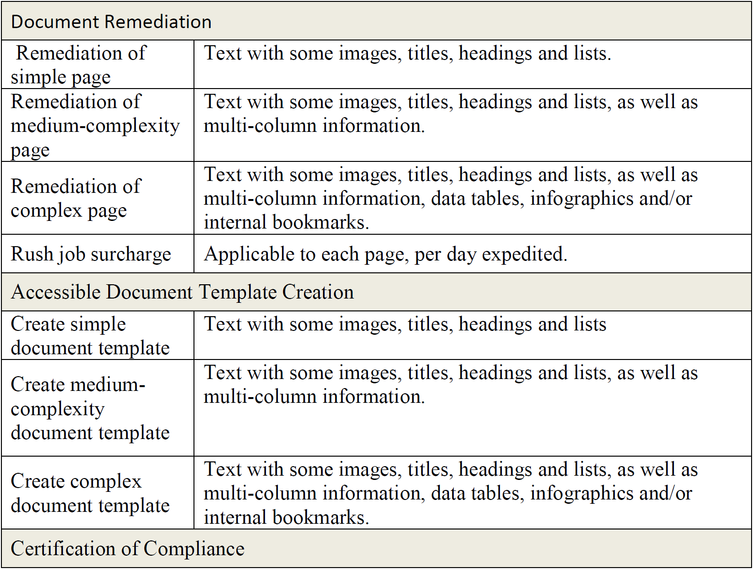

- Vendor/Contractor must submit quote on this form only.
- Quantities are for quoting purposes and do not represent the minimum or maximum the District is obligated or limited to purchase. Unit prices are required. If there is math error, the unit price will prevail.
- If any proprietary, trade, brand or manufacturer’s name or part number is used to indicate the minimum standard of composition and acceptable quality, it shall not be construed to exclude products of equal or better functional capability and quality unless indicated “Do Not Substitute.” If an equivalent product is being quoted, it must be indicated, and documentation and/or samples may be required at no expense to the District.
- The resulting Purchase Order will be awarded based upon the best value and/or the lowest responsive and responsible quote(s) and will be governed solely by the terms and conditions attached. The District does not bind itself to accept the minimum specifications stated in this quote, but reserves the right to accept any quote that, in the judgment of the District, will best serve the needs and the interest of the District.
- The District reserves the right to award this Request for Quote to one or more Vendor/Contractor on a split order basis; lump sum basis, individual item basis, or such combination as shall best serve the interest of the District.
- Payment will be made in accordance with the Local Government Prompt Payment Act, Part VII of Chapter 218, Florida Statute.
- All prices must be F.O.B. destination unless otherwise agreed in writing by the District.

ITEM | DESCRIPTION | ESTIMATED QUANTITY | UNIT OF MEASURE | UNIT PRICE | TOTAL PRICE
1 | Remediation of Simple Document  Page | 1 | PER PAGE | $ | N/A
2 | Remediation of Medium  Complexity Document Page | 1 | PER PAGE | $ | N/A
3 | Remediation of Complex  Document Page | 1 | PER PAGE | $ | N/A
4

FOR EVALUATION PURPOSES ONLY:
The District will utilize the following quantities when comparing responses for evaluation purposes.
Unit Pricing must match Lines 1 – 3 above.
ITEM | DESCRIPTION | ESTIMATED QUANTITY | UNIT OF MEASURE | UNIT PRICE | TOTAL PRICE  (Estimated Quantity X Unit Price)
1 | Remediation of Simple Document  Page | 100 | PER PAGE | $ | $
2 | Remediation of Medium  Complexity Document Page | 2200 | PER PAGE | $ | $
3 | Remediation of Complex  Document Page | 200 | PER PAGE | $ | $
4

Vendor Notes: | Delivery/Freight Charges: | $
 | Discount: | $
 | Trade-in Allowance: | $
Delivery Days after Receipt of PO: Enter # of days. | QUOTE TOTAL: | $

INSURANCE REQUIRED: ☒YES ☐NO

If yes, the awarded Vendor shall name the District as a Certificate Holder as well as Additional Insured in regard to General Liability and Products Liability. Vendor shall maintain the coverage limits set forth throughout the duration of performing this scope of work at the Vendor sole expense.

Certificate of Insurance must be provided to the District prior to issuance of the Purchase Order.

Required Insurance Minimums:

General Liability $1,000,000 per occurrence / $2,000,000 aggregate

Worker’s Compensation Statutory

Employer’s Liability $500,000/$500,000/$500,000

REFERENCES REQUIRED: ☒ YES ☐ NO

If yes, Vendor must submit a minimum of three (3) references on Attachment 1 of this RFQ Form.
The references must be for projects of similar size and scope.

Indicate by checking the box below the number of days your prices shall remain firm from the date of quotation or indicate Quote expiration date in space provided:

☐ 30 days ☐ 60 days ☐ 90 days or Quote Expiration Date: Click to select a date.

Business Name: | Reason for No-Quote:
Contact Person Name:
Mailing Address:
City-State-Zip:
Telephone Number: | Toll-Free Number:
Email:

I the undersigned, as Quoter hereby declare that I have carefully read this Request for Quote and the resulting Purchase Order terms and conditions attached and fully understand the requirements. I certify that this quote is made without prior understanding, agreement, or connection with any corporation, firm, entity, or person submitting a quote for the same goods/services (unless otherwise specifically noted) and is in all respects fair and without collusion or fraud. I agree to be bound by all of the terms and conditions of this Request for Quote. I certify that I am authorized to sign this quote for the Quoter and that all the information provided is true and correct to the best of my knowledge.
Authorized Signature: Type signature or enter a space to handwrite _ signature. |  | Date:
Full Name: | Title:
Please visit the District’s website for our Tax Exempt Certificate and Vendor Registration Form at www.watermatters.org/procurement.

ATTACHMENT 1
REQUEST FOR QUOTE
REFERENCES FORM

Company Name:
Address:
Contact Person Name:
Contact Person Title:
Telephone Number:
Email:
Description of Work Performed:
Date Range:
Total Contract Amount:
Company Name:
Address:
Contact Person Name:
Contact Person Title:
Telephone Number:
Email:
Description of Work Performed:
Date Range:
Total Contract Amount:
Company Name:
Address:
Contact Person Name:
Contact Person Title:
Telephone Number:
Email:
Description of Work Performed:
Date Range:
Total Contract Amount:

PURCHASE ORDER TERMS AND CONDITIONS

This Purchase Order issued by the Southwest Florida Water Management District (District) constitutes a binding contract under the terms and conditions contained herein and on attachments hereto when accepted by the Vendor/Contractor named on this Purchase Order, either by acknowledgement or by shipment or by commencement of work.

- Vendor/Contractor will allow public access to documents and materials made or received by Vendor/Contractor in connection with this transaction in accordance with the Public Records Act, Chapter 119, Florida Statutes (F.S.).

- All invoices must include this Purchase Order number and be mailed to the “Bill To” address on the face of this Purchase Order. Payment will be made in accordance with the Local Government Prompt Payment Act, Part VII of Chapter 218, F.S. The District's payment and performance under this Purchase Order are contingent upon the District's Governing Board appropriating funds.

- Time is of the essence. This Purchase Order may be terminated by the District without cause by providing ten (10) days written notice to the Vendor/Contractor. If Vendor/Contractor fails to comply with any provision of this Purchase Order, the District will provide Vendor/Contractor with written notice of default and Vendor/Contractor will have ten (10) calendar days, or such other time as stated in the notice, to cure the default. If the default is not cured within the stated timeframe, this Purchase Order will terminate and the District will be entitled to recover re-procurement costs, attorneys' fees and costs, and any other expenses and costs incurred by the District. The District reserves the right to cancel this Purchase Order or any part hereof, without obligation, if Vendor/Contractor fails to complete delivery or performance within the specified time period. The rights and remedies in this paragraph are in addition to any other rights and remedies provided by law or under this Purchase Order. The District's waiver of any obligation of Vendor/Contractor will not be construed as the District's waiver of any other obligation of Vendor/Contractor.

- Vendor/Contractor agrees to indemnify and hold harmless the District and all District agents, employees and officers from and against all liabilities, claims, damages, expenses or actions, either at law or in equity, including attorneys' fees and costs and attorneys' fees and costs on appeal, caused or incurred, in whole or in part, as a result of any act or omission by the Vendor/Contractor, its agents, employees, subcontractors, assigns, heirs or anyone for whose acts or omissions any of these persons or entities may be liable during Vendor/Contractor's performance under this Purchase Order. Vendor/Contractor also agrees to defend all actions or claims brought against the District and hold harmless the District from all losses, costs or damages related to actual or alleged infringement of any patent, trademark or copyright. Vendor/Contractor's obligations contained in this paragraph will survive acceptance of the goods or services by the District.

- Vendor/Contractor agrees to comply with all applicable federal, state, and local laws relating to performance under this Purchase Order. The Vendor/Contractor will not discriminate against any employee or applicant for employment because of race, color, religion, sex, handicap, disability, marital status, or national origin.

- All aspects of this Purchase Order are subject to and governed by Florida laws, including without limitation, Section 768.28, F.S., and the provisions of the Uniform Commercial Code, Chapters 671 and 672, F.S. Any dispute arising from or related to this Purchase Order will be resolved in a court of competent jurisdiction in the State of Florida and venue will lie in Hernando County.

- In accordance with Sections 287.133(2)(a) and 287.134(2)(a), F.S., Vendor/Contractor warrants that it is not currently on the convicted vendor list or the discriminatory vendor list, it has not been placed on a convicted vendor list in the past 36 months and agrees to notify the District if placement on either of these lists occurs. If subcontracting is allowed under this Purchase Order, Vendor/Contractor agrees to include this provision in all subcontracts issued as a result of this Purchase Order.

- Vendor/Contractor providing services to the District will obtain and maintain commercial general liability insurance, vehicle liability insurance, and workers' compensation coverage to the District's satisfaction. Vendor/Contractor will also require the same insurance from any subcontractor; otherwise, such coverage will be afforded to the subcontractor by the Vendor/Contractor's insurance policies. Such insurance will be available for District review upon request.

- Unless otherwise provided herein, no party may assign or delegate any of its rights and obligations under this Purchase Order, voluntarily or involuntarily, whether by merger, consolidation, dissolution, operation of law, or any other manner without the prior written consent of the other party and the parties agree that any unauthorized assignment is null and void.

- This Purchase Order constitutes the entire agreement between the parties and any changes must be mutually agreed to in writing by authorized representatives of the parties. This Purchase Order shall be binding upon and inure to the benefits of the parties hereto and their respective heirs, successors, assigns, executors, administrators, and legal representatives where permitted.

- All materials, drawings or other items provided by the District to Vendor/Contractor will remain the property of the District and will be returned to the District upon demand. All containers, reels or pallets shipped with goods by Vendor are to remain the property of the District unless otherwise agreed.

- Materials will be properly packaged and marked with the Purchase Order number.

- Inspection of items will be made at the destination, unless otherwise specified, and before payment is due. The District reserves the right to reject any goods which are defective or not in accordance with specifications as to quality or performance. Title to property passes only after inspection and acceptance by the District. Rejected materials will be returned to the Vendor at the Vendor's risk and expense.

- All prices must be F.O.B. destination unless otherwise agreed in writing by the District. Where a specific purchase is negotiated F.O.B shipping point, the Vendor will prepay shipping charges and include them on the invoice.

- Quantities and prices specified herein are not to be exceeded unless authorized in writing in accordance with paragraph 10 of this Purchase Order. The Vendor's price will be the lowest prevailing market price and under no circumstances will the price be higher than specified herein without the express written authorization of the District.

- Vendor agrees to furnish the District with a current Material Safety Data Sheet (MSDS) on or before delivery of each and every hazardous chemical or substance purchased. Appropriate labels and MSDSs shall be provided for all shipments.

- Vendor warrants that the goods will conform to the specifications, drawings, and descriptions listed in the offering document or the sample(s) furnished.

SERVICES - ADDITIONAL TERMS AND CONDITIONS

- The Contractor will perform as an Independent Contractor and not as an employee, representative or agent of the District. If subcontracting is permitted under this Purchase Order, nothing herein will be construed to create or be implied to create any relationship between the District and any subcontractor of Contractor.

- The Contractor, upon request, will permit the District to examine or audit all records and documents related to the services performed under this Purchase Order during or following completion of the services. The Contractor will maintain all such records and documents for at least three (3) years following completion of the services and final payment by the District.

- All documents, including reports, drawings, estimates, programs, manuals, specifications, and all goods or products, including intellectual property and rights thereto, purchased under this Purchase Order with District funds or developed in connection with this Purchase Order will be and will remain the property of the District.

- In the event of any national, state or local emergency which significantly affects Vendor/Contractor's ability to perform, such as hurricanes, tornados, floods, acts of God, acts of war, or other such catastrophes, or other man-made emergencies beyond the control of the Vendor/Contractor such as labor strikes or riots, then the Vendor's/Contractor's obligation to complete said work within the time frames required by this Purchase Order will be suspended for the period of time the condition continues to exist. The foregoing will constitute the Vendor/Contractor's sole remedy or excuse with respect to the delay and no claim for damages, other than for an extension of time, will be asserted against the District.

ALTERNATIVE TERMS AND CONDITIONS

If Vendor/Contractor is a public entity, the following provision shall replace paragraph 4 of this Purchase Order:
- Each party hereto agrees to indemnify and hold the other harmless, to the extent allowed under Section 768.28, F.S., from all claims, loss, damage, and expense, including attorney fees and costs and attorney fees and costs on appeal, arising from the negligent acts or omissions of the indemnifying party's officers, employees, contractors, and agents related to its performance under this Agreement. This provision does not constitute a waiver of either party's sovereign immunity or any lawful defenses or extend either party's liability beyond the limits established in Section 768.28, F.S. The obligations contained in this paragraph will survive acceptance of the goods or services by the District.

The District expects the Contractor to make good faith efforts to ensure that disadvantaged business enterprises, which are qualified under either federal or state law, have the maximum practicable opportunity to participate in contracting opportunities under this Purchase Order. Invoice documentation submitted to the District under this Purchase Order must include information relating to the number of expenditures made to disadvantaged businesses by the Contractor in relation to this Purchase Order, to the extent the Contractor maintains such information.

If Contractor is a design professional under 725.08, F.S., the following provision shall replace paragraph 4 of this Purchase Order:
- Contractor's liability is limited as provided in this Section 22. Contractor agrees to indemnify and hold harmless the District and all District officers and employees, from liabilities, damages, losses, and costs, either at law or in equity, including, but not limited to reasonable attorney fees and costs and attorney fees and costs on appeal, as a result of any negligent or reckless act or omission or any intentionally wrongful conduct by the Contractor and other persons employed or utilized by the Contractor in the performance of this Purchase Order in accordance with Section 725.08, F.S. Contractor's obligations contained in this paragraph will survive acceptance of the services by the District.

ADDENDUM TO PURCHASE ORDER
SOUTHWEST FLORIDA WATER MANAGEMENT DISTRICT

This Addendum is hereby incorporated into and made a part of this Purchase Order.

1. Paragraph 1 of the Purchase Order Terms and Conditions is herby replaced with the following:

PROJECT RECORDS AND DOCUMENTS

1.1 The VENDOR/CONTRACTOR, upon request, shall permit the DISTRICT to examine or audit all SERVICES related records and documents during or following completion of the SERVICES at no cost to the DISTRICT. These records shall be available at all reasonable times for inspection, review, or audit. "Reasonable" shall be construed according to circumstances, but ordinarily shall mean normal business hours of 8:00 a.m. to 5:00 p.m., local time, Monday through Friday. In the event any work is subcontracted, the 2D PARTY shall similarly require each subcontractor to maintain and allow access to such records for inspection, review, or audit purposes. Payments made to the VENDOR/CONTRACTOR under this Agreement shall be reduced for amounts found to be not allowable under this Agreement by an audit. If an audit is undertaken by the DISTRICT, all required records shall be maintained until the audit has been completed and all questions arising from it are resolved. The VENDOR/CONTRACTOR shall maintain all such records and documents for at least five (5) years following completion of the SERVICES. If an audit has been initiated and audit findings have not been resolved at the end of the five (5) years, the records shall be retained until resolution of the audit findings, which would include an audit follow-up by the inspector general if the findings result from an external auditor, or any litigation. The 2D PARTY and any subcontractors understand and will comply with their duty, pursuant to Section 20.055(5), F.S., to cooperate with the inspector general in any investigation, audit, inspection, review, or hearing.

1.2 Each party shall allow public access to the SERVICES documents and materials made or received by either party in accordance with the Public Records Act, Chapter 119, F.S. To the extent required by Section 119.0701, F.S., the VENDOR/CONTRACTOR shall (1) keep and maintain public records required by the DISTRICT to perform the SERVICES; (2) upon request from the DISTRICT’S custodian of public records, provide the DISTRICT with a copy of the requested records or allow the records to be inspected or copied within a reasonable time at a cost that does not exceed the cost provided by law; (3) ensure that public records that are exempt or confidential and exempt from public records disclosure requirements are not disclosed except as authorized by law for the duration of the term of this Agreement and following completion of the Agreement if the VENDOR/CONTRACTOR does not transfer the records to the DISTRICT; and (4) upon completion of this Agreement, transfer, at no cost to the DISTRICT, all public records in possession of the VENDOR/CONTRACTOR or keep and maintain public records in possession of the VENDOR/CONTRACTOR to keep and maintain public records required by the DISTRICT to perform the SERVICES. If the VENDOR/CONTRACTOR transfers all public records to the DISTRICT upon completion of this Agreement, the VENDOR/CONTRACTOR shall destroy any duplicate public records that are exempt or confidential and exempt from public records requirements. If the VENDOR/CONTRACTOR keeps and maintains public records upon completion of this Agreement, the VENDOR/CONTRACTOR shall meet all applicable requirements for retaining public records. All records stored electronically must be provided to the DISTRICT, upon request from the DISTRICT’S custodian of public records, in a format that is compatible with the information technology systems of the DISTRICT.

1.3 IF THE VENDOR/CONTRACTOR HAS QUESTIONS REGARDING THE APPLICATION OF CHAPTER 119, FLORIDA STATUTES, TO THE VENDOR/CONTRACTOR’S DUTY TO
PROVIDE PUBLIC RECORDS RELATING TO THIS AGREEMENT, CONTACT THE CUSTODIAN OF PUBLIC RECORDS by telephone at 352-205-8482, by email at
RecordsCustodian@Watermatters.org, or at the following mailing address:

Public Records Custodian
Southwest Florida Water Management District
2379 Broad Street
Brooksville, Florida 34604-6899

Any changes to the above contact information will be provided to the VENDOR/CONTRACTOR in writing.

1.4 This Paragraph, including all subparagraphs, shall survive the expiration or termination of this Agreement.

