Response to Mr. Miller’s email request:

1. Item 4 on the agenda --- Water Use Permitting
Please provide a table and map of all of the water withdrawal permits in the Homosassa Springs Springshed.

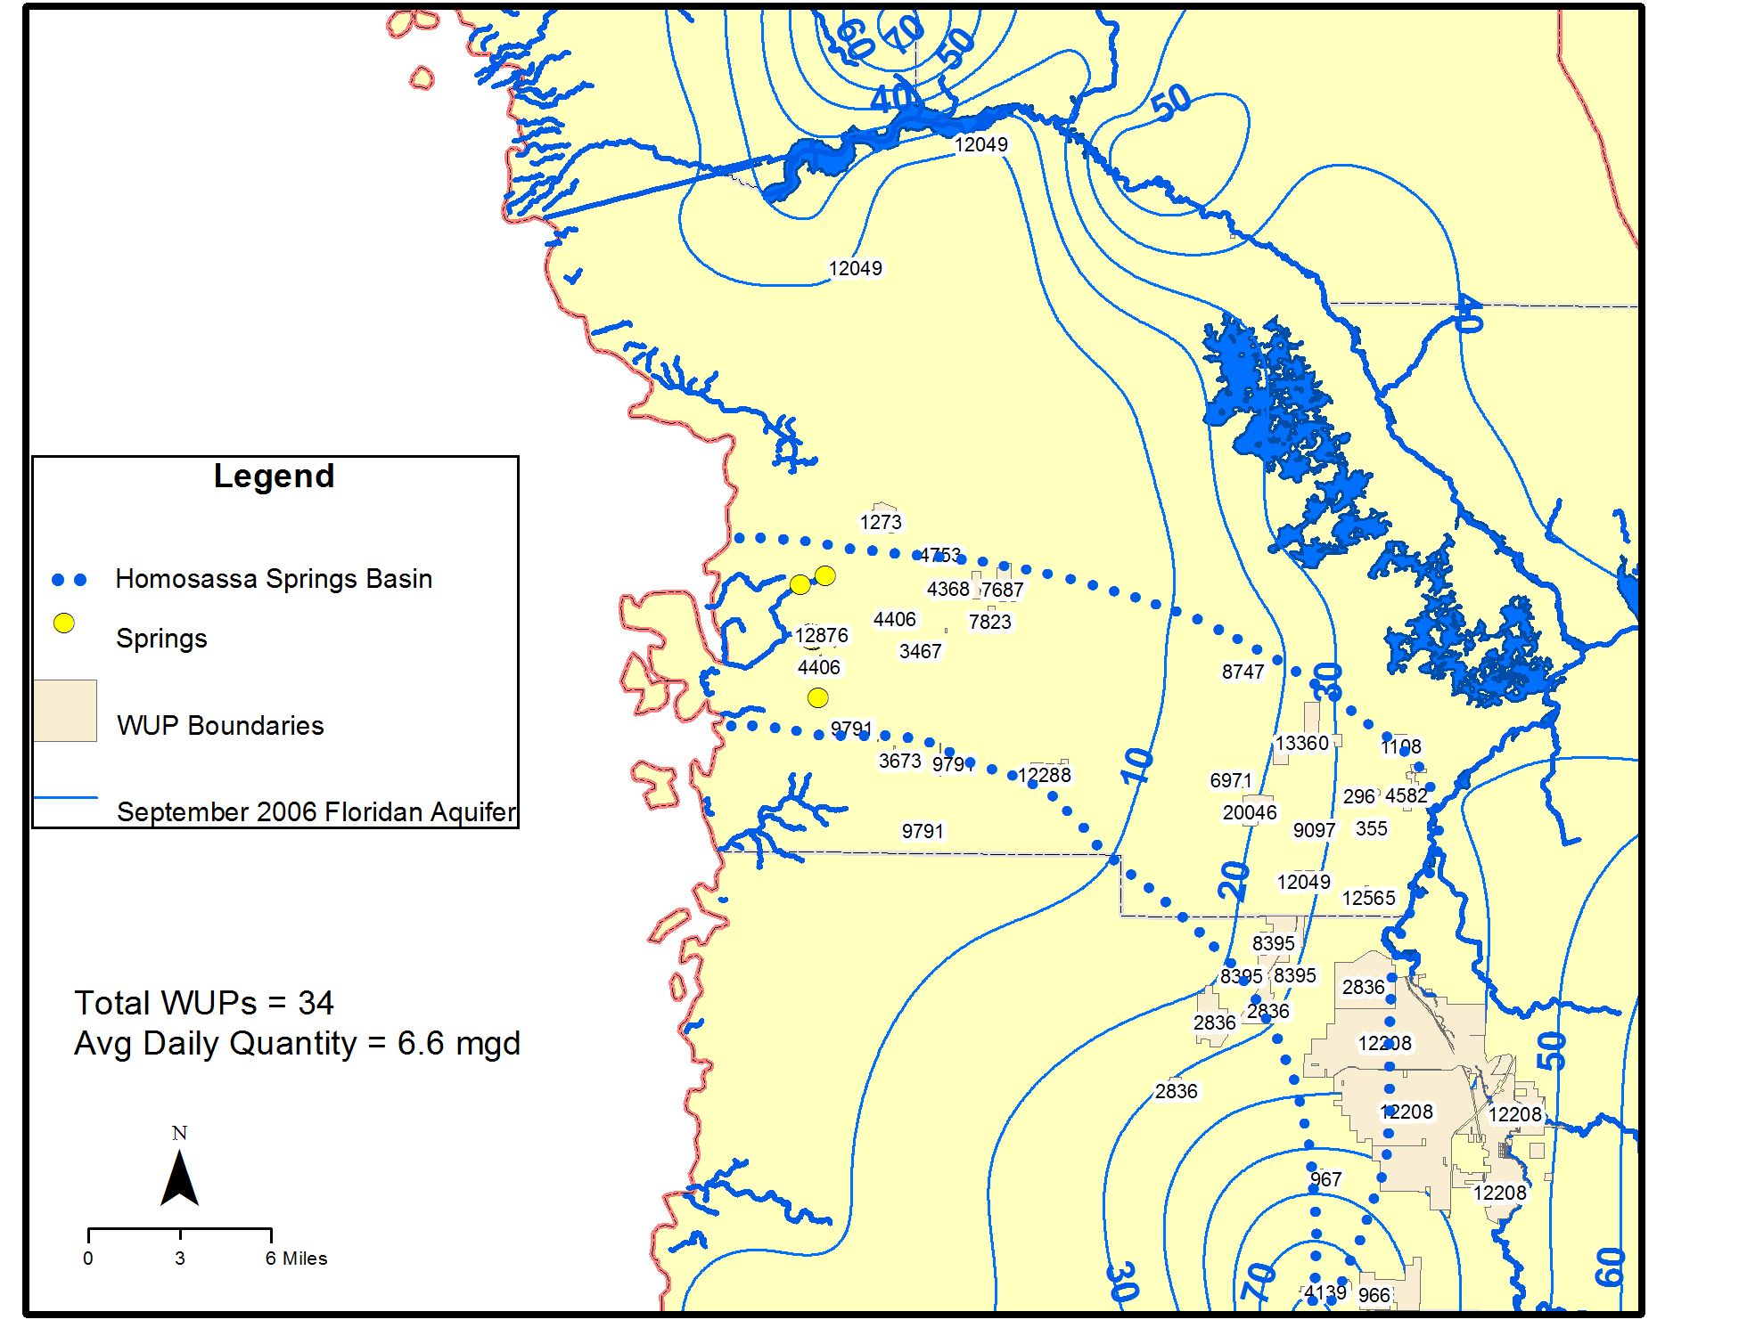

 |  |  |  |  | AVG DAILY
WUP_PERMIT | WUP_REVISI | PERMITTEE_ | WATER_USE_ | OWNED_PROP | PERMITTED_GPD
296 | 2 | Ray A Morris | AGRICULTURAL | 37 | 11,100
355 | 2 | L Norman And Linda L Adams | AGRICULTURAL | 18 | 22,600
967 | 3 | Hickory Hills Land Company, ATTN: Robert Thomas | AGRICULTURAL | 93 | 68,100
1108 | 4 | Z2F Citrus & Cattle LLC | AGRICULTURAL | 105 | 99,000
1273 | 4 | Post Oak Ranch LLC | AGRICULTURAL | 533 | 61,500
2226 | 3 | Edwin O'Neal | AGRICULTURAL | 20 | 27,450
2836 | 3 | United States Dept Of Agriculture | AGRICULTURAL | 3817 | 21,400
4139 | 3 | Aam Family Ltd Partnership | AGRICULTURAL | 51 | 58,500
4582 | 2 | Thomas W. & Mary L. Harrison | AGRICULTURAL | 280 | 31,800
5091 | 3 | Toby John & Joanna Caulfeild | AGRICULTURAL | 20 | 300
6966 | 4 | Larry W & Ruth A Davis | AGRICULTURAL | 48 | 29,400
6971 | 2 | John W & Margaret R White | AGRICULTURAL | 51 | 30,900
7687 | 7 | Crystal River Quarries Inc | AGRICULTURAL | 460 | 62,050
8747 | 1 | William Hunt | AGRICULTURAL | 14 | 2,900
12146 | 1 | Edwin E. and Barbara A. Harbour | AGRICULTURAL | 20 | 9,280
12208 | 0 | Board Of Trst'S Improv'T Tst Fnd Fdep-Div Of Rec & Parks Bureau | AGRICULTURAL | 21639 | 143,400
12288 | 2 | M & B Products | AGRICULTURAL | 322 | 497,277
12565 | 0 | Professional Horticultural Services | AGRICULTURAL | 80 | 385,700
13360 | 0 | Throgmartin-Henke Ranch & | AGRICULTURAL | 0 | 231,500
20046 | 0 | Pinewoods Plantation Nursery Inc | AGRICULTURAL | 489 | 123,160
9115 | 1 | Tru Gas Of Florida, Inc. | INDUSTRIAL AND COMMERCIAL | 1 | 1,000
12049 | 1 | Citrus Co Bocc | INDUSTRIAL AND COMMERCIAL | 33 | 2,500
4368 | 2 | Citrus County School Board | PUBLIC SUPPLY | 160 | 161,000
4406 | 7 | Homosassa Special Water District | PUBLIC SUPPLY | 10 | 960,000
4753 | 3 | Constate Utilities Inc | PUBLIC SUPPLY | 1 | 81,200
7823 | 2 | Central Florida Community College | PUBLIC SUPPLY | 87 | 11,800
8395 | 3 | Board Of Tst Internal Improv Tst Fund Of The State Of Florida | PUBLIC SUPPLY | 1116 | 5,900
9097 | 2 | Tarawood Utlities LLC | PUBLIC SUPPLY | 5 | 99,600
9791 | 7 | Citrus County Water Resources De c/o Robert Knight Director | PUBLIC SUPPLY | 2 | 2,064,000
13290 | 0 | Citrus Co Dept Of Public Works Glenn Mccracken Pe | PUBLIC SUPPLY | 19 | 9,400
966 | 4 | Hickory Hills LLC | RECREATION/AESTHETIC | 2766 | 775,000
3467 | 2 | Gibraltar Mausoleum Of Florida | RECREATION/AESTHETIC | 40 | 45,400
3673 | 5 | Suntacc & Company, Inc. | RECREATION/AESTHETIC | 250 | 456,000
12876 | 1 | Board Of Trustees Internal Imp & Homosassa Springs Wildlife Prk | RECREATION/AESTHETIC | 203 | 12,600
 |  |  |  | Total: | 6,602,717

There are a total of 34 water use permits within or near the Homosassa springshed as of December 2010. Total average daily permitted quantities for groundwater use is 6.6 mgd. They break down as follows:

WUP Type | No. of Permits | Avg Daily Quantity (mgd)
Agriculture | 20 | 1.92
Industrial/Commercial | 2 | 0.003
Mining | 0 | 0
Public Supply | 8 | 3.39
Recreation | 4 | 1.29

There are 134 water use permitted wells within or near the Homosassa springshed. Total average daily permitted quantity from all 134 wells is 6.32 mgd. Slight differences in the total occur because some of the WUPs under the same permit number have parcels that are within and outside the springshed (i.e. 2836, 9791, 12049). A few of the permits include quantities outside the springshed and thus the permitted total is slightly higher than the sum of the wells.

Estimated and metered water use in the springshed for 2005 was 3.7 mgd from 143 wells.

2. Item 5 on the Agenda --- Groundwater and Withdrawal Modeling
These questions are with regard to the Northern District Model (NDM).

A. How does the model represent the underground flows including the fast flowing deep cracks and channels of the limestone foundation?

The NDM contains a finite-difference grid that consists of 182 columns and 275 rows of 2,500 ft uniformly spaced cells. The NDM is fully 3-Dimensional with top and bottom elevations specified for each model layer. Topographic elevations were assigned to the top of model layer 1 from a digital elevation model provided by SWFWMD, based on the USGS 30m National Elevation Dataset. The Florida Geological Survey supplied elevation data for all other layers in the model.

The NDM consists of seven layers that represent the primary geologic and hydrogeologic units including: 1. Surficial Sands; 2. Intermediate Confining Unit (ICU); 3. Suwannee Limestone; 4. Ocala Limestone; 5. upper Avon Park Formation; 6. Middle Confining Unit (MCU) I and MCU II; and 7. lower Avon Park Formation or Oldsmar Formation. The UFA is composed of the Suwannee Limestone, Ocala Limestone, and Upper Avon Park; the Lower Floridan aquifer (LFA) is composed of the permeable parts of both the lower Avon Park and the Oldsmar Formation. Due to the permeability contrasts between the units, each unit is simulated as a discrete model layer rather than using one model layer to represent a thick sequence of permeable units (e.g., UFA).

The NDM was calibrated to steady-state 1995 calendar year conditions and transient conditions from 1996 through 2002 using monthly stress periods. The model has recently been extended through 2006 (Version 3.0). This model is unique for west-central Florida in that it is the first regional flow model that represents the groundwater system as fully three-dimensional. Prior modeling efforts, notably Ryder (1985), Sepulveda (2002), and Knowles and others (2002), represented the groundwater system as quasi-three-dimensional.

The numerical model simulates hydrogeologic conditions through assignment of aquifer parameters that are based on aquifer performance testing, other hydraulic tests, prior knowledge, and geologic characteristics. A conceptual model of the system was developed prior to construction of the NDM whereby field data and other data from reports were analyzed to more fully understand the physical system. NDM parameters were adjusted within reasonable ranges based the hydrogeology of the system during the calibration process. Localized karst features such as cracks, conduits, or channels in the subsurface are integrated in the model over a 2,500 ft cell size through equivalent porous media parameterization in the model.

B. How is the interaction with the salt water interface modeled?

The NDM simulates the fresh groundwater flow system within its domain. The potential movement of solutes (salts and minerals) can only be addressed through a transport model which is a completely different code. The District simulated the movement of the saline water interface in a separate saltwater intrusion model that is described at the end of the NDM report (Hydrogeologic, 2008). Detailed information on the model calibration is included in the 2008 report by Hydrogeologic, Inc., titled Groundwater Flow and Saltwater Intrusion Model for the Northern District Water Resources Assessment Project Area, Version 1.0. A subsequent version (2.0) was completed in 2010.

C. How is rainfall and water seepage from outside the area modeled?

The active domain of the NDM includes all of the Northern West-Central Florida Ground-Water Basin (NWCFGWB) of the Floridan aquifer. In addition, most of Lake County outside the NWCFGWB is also included in the model to assess water use near the SWFWMD eastern boundary. A groundwater basin has well-defined boundaries in a lateral direction with a definable bottom. Rainfall that falls within a groundwater basin provides recharge to the aquifer within that basin. Groundwater does not flow laterally between groundwater basins or outside of a basin.

Rainfall is converted to recharge in the model based on the following equation:

Rainfall – ET- Runoff = Recharge

Recharge is calculated outside the model based on radar-estimated rainfall, runoff, and evapotranspiration rates calculated based on land cover and water table depth. Once calculated, recharge is applied to layer 1 of the model. A detailed explanation is given in Groundwater Flow and Saltwater Intrusion Model for the Northern District Water Resources Assessment Project Area, Version 1.0, Hydrogeologic, Inc. 2008.

D. How does the model account for the delay between the time of the increasing rain fall and the time of increased spring flow?

The groundwater flow model simulates changes in aquifer levels, baseflow, and spring flow due to variations in stress. The principle stress components are recharge and pumping. The model is calibrated to the 1995 through 2006 period by matching well water levels and measured or estimated flows. Water budget values were calculated on a basin-wide basis for the 1995 steady-state and 1996-2006 transient models (Version 3.0). These values were generally consistent with empirical water budget estimates and previous models of the area. If the model simulates variations in aquifer head and flows consistent with observed values, then it provides confidence that the model is adequately accounting for variations in spring flow due to rainfall.

E. What are the model calibration methods and what data supports the agency claim of 2% prediction accuracy?

I’m not sure the agency claimed a “2% prediction accuracy”, only that the model matches observed spring flows within two percent during the calibration period. The NDM calibration methods consisted of automatic and manual best-fit parameter adjustments to minimize aquifer head and flow error. General calibration statistics were to achieve a 10% or less match in observed versus simulated total flows for baseflow and spring flow. A mean error close to 0 ft and a mean absolute error of 4 ft were targeted for the Northern West-Central Florida Groundwater Basin observation wells in each aquifer.

In the 1995 steady-state model simulated flows for the Homosassa and Chassahowitzka group springs were generally within two percent of the observed (estimated) values. I’ve attached Table 4.7 from version 2.0 of the NDM that shows the difference between model simulated and observed flow rates for the nature coast

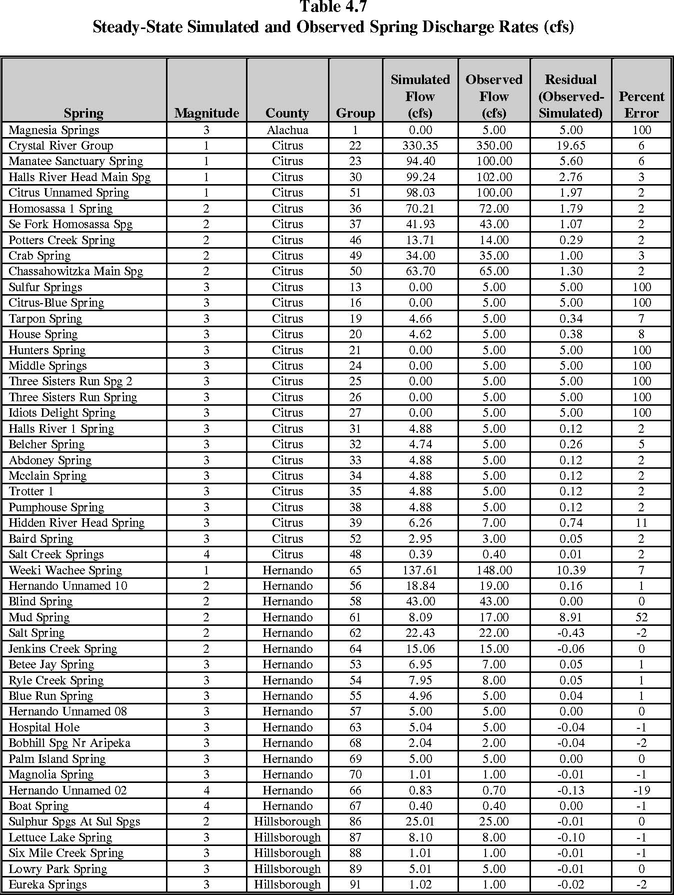
springs.

F. What are the actual measured and predicted flows for the Homosassa Springs Group flows for conditions that represent 1946, 1966, 1970, 1979, 1990, 2010 and 2030?

Flows are not measured for most of the springs within the Homosassa Springs Group. The NDM matches estimated or observed flows for 1995 and on a monthly basis from 1996 through 2006 for the Chassahowitzka main spring and Homosassa 1 spring (in Version 3.0). Once a model is calibrated, there are no further adjustments to aquifer parameters. Future scenarios are run by simply altering well withdrawals to fit a given condition (ex. 2030). There are no modeled flows outside the 1995-2006 period except for the non-pumping and 2030 prediction scenarios. Table 2 shows the predicted spring discharge rates in the 2030 simulation. Homosassa No. 1 spring’s continuous discharge record starts in 1995. There are no continuously measured flows prior to 1995.

Table 2. Predicted Homosassa Spring group discharge under non-pumping and 2030 conditions.

Spring Name | Discharge for Non-Pumping Scenario (cfs) | Discharge for 2030 Pumping Scenario (cfs) | Difference (cfs) | Percent Difference
Abdoney Spring | 4.98 | 4.87 | -0.11 | -2.13
Belcher Spring | 4.98 | 4.77 | -0.21 | -4.29
Halls River 1 Spring | 5.00 | 4.90 | -0.10 | -2.07
Halls River Head Main Spg | 102.11 | 99.76 | -2.35 | -2.31
Hidden River Head Spring | 6.61 | 6.05 | -0.56 | -8.47
Homosassa 1 Spring | 71.65 | 70.16 | -1.49 | -2.07
Mcclain Spring | 4.98 | 4.87 | -0.11 | -2.13
Pumphouse Spring | 4.97 | 4.87 | -0.10 | -2.10
Trotter 1 | 4.97 | 4.87 | -0.10 | -2.02
Total | 210.2 | 205.12 | -5.13 | -2.44

G. Does the model show that the drawdown of underground water alters the relative flows between the Weeki Wachee, Chassahowitzka, Homosassa and Crystal River Rivers?

The NDM is used as a predictive tool to model impact to all 93 springs in the domain. Groundwater withdrawn in the entire Northern West-Central groundwater Basin can impact spring discharge. However, the magnitude and proximity of withdrawals to the spring vent directly influences the potential impact to spring flow. The closer the withdrawal and greater the pumpage causes a larger decline in flow compared to a withdrawal much further away. Predicted impact to Weeki Wachee spring is much greater than the other springs due to relatively large groundwater withdrawals for Hernando County utilities and Cross Bar wellfield within the springshed. The drawdown in the Upper Floridan aquifer water level and spring discharges from 93 springs have been modeled for 2005 and 2030 conditions (when compared to a “pumps off” condition) to note change due to all withdrawals.

H. Does the model show that you can control different percent flow draw downs independently across the four above mentioned springsheds?

Not sure what you mean here. Predicted impacts vary amongst the four main spring groups due primarily to the proximity and magnitude of well withdrawals to each spring network, aquifer parameters near the springs, and variation in recharge to the Upper Floridan aquifer near each spring.

I. What happens to the Homosassa Springs when the Chassahowitzka is drawn down by 11%?

Since the allowable flow has been proposed at five percent for Homosassa Spring it is likely that this will limit groundwater withdrawals in the area so that impacts to Chassahowitzka will never reach 11%.

J. What happens to the Bluebird Springs when the Chassahowitzka is drawn down by 11%?

Bluebird springs is not actively simulated in the NDM. If Bluebird Springs is close to the Chassahowitzka Springs group, it’s likely it’ll be affected in a similar way.

