Outdoor Recreation Hispanic Outreach

Background:

If the census results are any indicator, Hispanics are currently the fastest-growing minority group in the nation. If this trend continues, Hispanics will represent 25 percent of the U.S. population by 2050. It is not just their growth in numbers that is making this market so appealing to large retailers, but rather their spending power. The combined purchasing power of Hispanics, as reported by HispanTelligence®, is estimated at $1 trillion. With this noticeable growth in the past ten years, it is only natural that companies have been increasing their marketing strategies to attract the Hispanic market. In order for these strategies to work, they must be careful not to treat Hispanics as a homogenous group or stereotype their cultures. Hispanics need to be treated as a unique population with their own characteristics and ways of living. Therefore, the marketing strategies used for the general market must be changed in order to attract Hispanic consumers and their families.
Marketers must also be wary of the differing generation gaps. First-, second- and third-generation Hispanics are all of different ages and receive information differently. This is crucial when determining who and how to target the different generations. Outdoor Industry Foundation found that Hispanics value family, community and personalization, in that same order. These results hold the key to successfully reaching a population whose continued growth and purchasing power is making them a significant segment of the District’s audience.

Statistical Information Illustrating Hispanic Growth
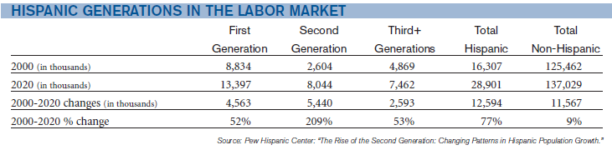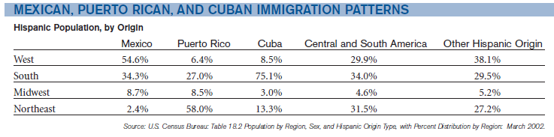
New Lifers and Old Ways: These groups of people are 100 percent foreign born, predominantly speak Spanish and are less assimilated into American culture.
Settled In, Pioneers and Young Americans: These groups of people are primarily U.S. born, prefer English and are more assimilated into American culture.
Although these two sets of groups vary vastly in their acculturation levels and their dominant language, they have a unifying theme. All these segments speak some Spanish.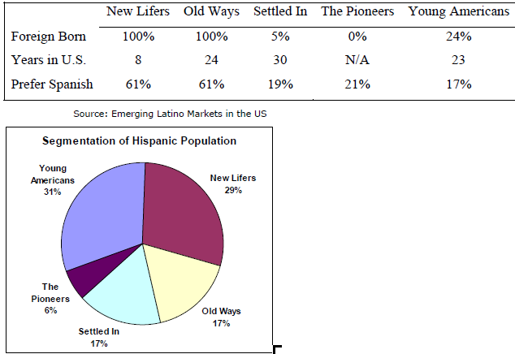
Most popular outdoor activities within the Hispanic segment
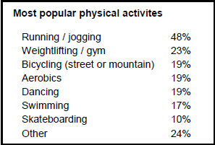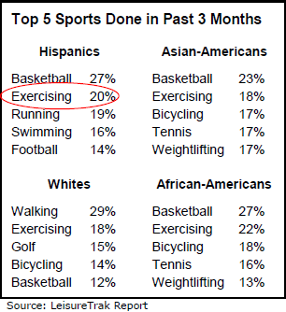
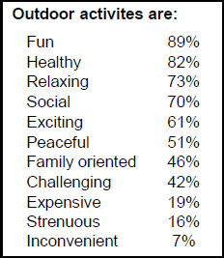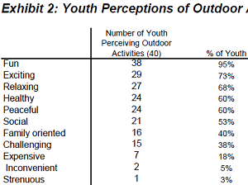

Barriers:
As with any group, there are always difficulties in the distribution of information. Marketers are always looking for new ways to attract the attention of different age groups. This task is suddenly harder when it comes to the Hispanic demographic. Because of its complex dynamics, Hispanics require more detail and attention than the general market.
First-generation Hispanics:
- Most likely to speak, read and get their information in Spanish. The challenge with this generation is showing them that they are represented and accounted for in marketing campaigns. Some typical trends of this group include:
  - Listens to mostly Spanish language radio 40 percent of the time.
  - Watches mostly Spanish language television 50 percent of the time.
  - Media consumption habits: About 90 percent Spanish-language media.

- Do not participate in outdoor activities for the following reasons:
  - Lack of time
  - Perception of discrimination; fear of not being liked
  - Feeling uncomfortable around non-Latinos
  - Limited English proficiency
  - Lack of ethnic diversity of agency workforce
  - Accessibility/Distance
  - Lack of necessary equipment (bicycle, walking shoes, fishing gear, etc.)

Second-generation Hispanics:
- Somewhat of a hybrid between two worlds: English-speaking and Spanish. This generation is the most balanced of the three. People in this generation find themselves easily going from Spanish media to English. Their media consumption is evenly divided between these two languages and they are truly the most bicultural and bilingual in the sense that they can read, write, speak and understand both languages.
- Some challenges with the second- and third-generation markets include:
  - Promoting options that could substitute their usual gym activities.
  - Ensuring that there is a balance between the English and Spanish marketing strategies (not too much of one or the other).
  - Promoting the health and social benefits of outdoor recreation.
  - Parental consent to allow their children to attend day and overnight summer camps.
Benefits:

There are numerous benefits of outdoor recreation. First, the interest in outdoor activities is already present with Hispanics of all ages. Several other government organizations have already put in place programs targeting the Hispanic population in their respective regions. The Hispanic outreach works to close the gap between Hispanics and the non-Hispanics present in the community.
- Hispanics will force transitions in the U.S. economy therefore enabling them to use their buying power toward the purchase of outdoor items for use in a recreational trip.
- Hispanic youth now account for more than 34 percent of the total U.S. Hispanic population and more than 18 percent of the total U.S. youth population which makes them a prime target in the promotion of outdoor activities.
- Hispanics spend two-thirds of what non-Hispanics spend on recreational trips.
  - Focus of the recreational trips:
    - Bicycling
    - RV
    - Spending a day at the park is a tremendously popular option.
    - Cook outs
    - Softball, and soccer games
    - Soak up the sun
    - Music
- Hispanics are gaining more leisure time every year allowing for more outdoor opportunities.
- Hispanics take more sports vacations each year than non-Hispanic whites, African Americans and Asians.
- Hispanics have/develop a strong loyalty/relationship with services where they feel most welcome and understood.
- Hispanics tend to spend greater portions of their home income on entertainment and children than non-Hispanics therefore allowing them to consider outdoor activities when planning day and weekend trips.
- By reaching out to the Hispanic population and making them feel welcome in their respective communities, a trust will be built and they will tell other people, since most Hispanic news, whether good or bad, is conveyed through word of mouth.

Recommendations:
There are different ways in which the District can reach out to the Hispanic population within its 16 counties. Some of these are more accessible than others and some are simpler and easier than others. These recommendations help ease the barriers stated above and ultimately bring together the community, regardless of race or ethnicity.
- Grassroots campaign: Teaming up with local Hispanic leaders/community organizations to help support and endorse outdoor activities on District lands.
- Partner with schools and churches: Get in touch with local schools and churches to help promote the lands and the different ways to conserve water.
- Partner with retailers to sponsor outings: By reaching out to local Hispanic businesses and providing in-store materials, as well as out-of-store activities at the local lands with the employees/customers, this may raise awareness throughout the community.
- Use the Spanish language. Offer materials related to outdoor activities in Spanish. This demonstrates an attempt to reach out to Hispanics on a more personal level.
  - Signs
  - Maps
  - Website
  - Direct mail
  - Brochures
  - Multimedia
- Emphasize commitment to Hispanic segment:
  - Hiring practices: Recruiting bilingual representatives on site will help Hispanics feel more welcome and will allow them to feel comfortable.
- Present outdoor activities as an alternative form of family entertainment that are easy and do not require any extra time commitments.
- Target the parents, particularly the mother, but don’t forget to paint a picture of a family that includes extended family as well.
- Increase the marketing on simple and popular outdoor activities such as:
  - Hiking
  - Biking
  - Camping
  - Fishing
  - Jogging/walking
- Emphasize the health and social benefits to spending time in the outdoors.
What not to do:
The following can completely derail any efforts when reaching out to the Hispanic population:
- Treat Hispanics as a homogenous group: Be careful not to generalize all ethnicities into one. Each has different traditions and backgrounds that impact how they respond to the different information presented to them.
- Assume all demographics respond similarly: Do not attempt to reach out to all the generations through one medium, but rather use the most popular way within the age/generation group.
  - First generation:
- Respond through direct mail better than second and third generations.
- Information completely in Spanish is best: radio, TV, websites, newspaper, direct mail.
  - Second and third generation:
- Respond better to more online attempts. The information can be in either language for second generation; English would work best for third-generation Hispanics.
- Respond best to TV, online ad, radio, mobile-friendly websites.
- Assume all Hispanics are low-income and cannot afford to participate in and purchase outdoor-related products:
  - The Hispanic population now has a $1 trillion spending power, which makes them attractive to many companies seeking to tap into this market.

