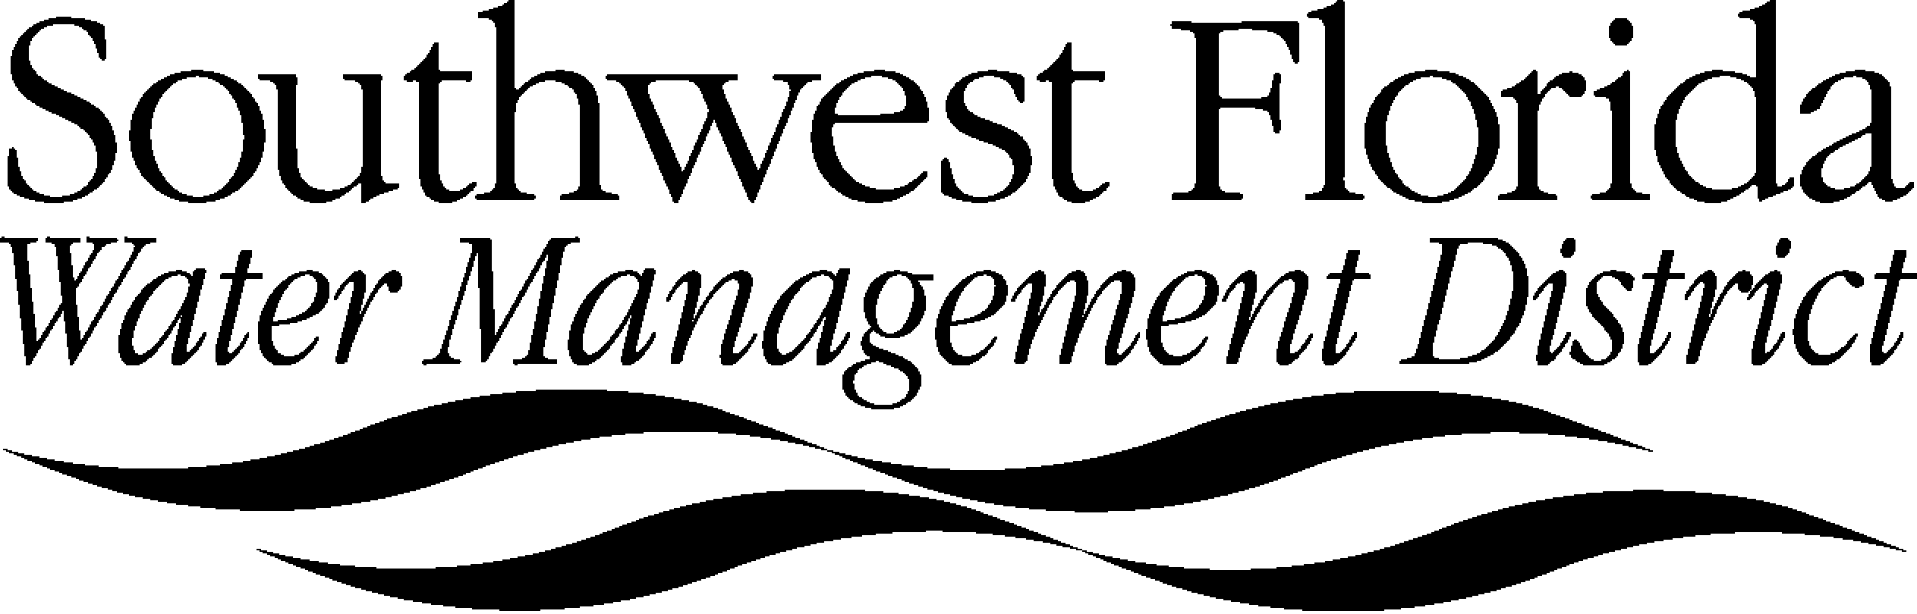

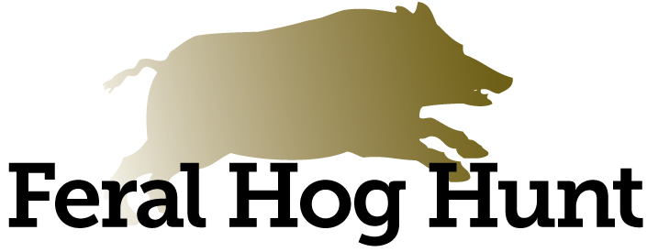

**RELEASE AND WAIVER OF LIABILITY**

THE UNDERSIGNED being (check one) __ at least 18 years of age (“Hunter”), or __ younger than 18 years of age and accompanied by a parent/guardian (hereby collectively, the “Young Hunter”), requests permission to participate in hog hunting (“Activity”) on property owned by the Southwest Florida Water Management District (“District”) and acknowledges reading and accepting the following Release, and states as follows:

1. The Undersigned acknowledges receiving and understanding all rules associated with the Activity.
2. The Undersigned fully understands that the Activity is dangerous and wishes to participate in the Activity knowing it to be dangerous. The Undersigned assumes the risks of injury, associated with but not limited to the Activity, outdoors in natural habitat, traversing both natural and man-made terrains, working with dogs, exposure to harmful organisms, interactions with wild animals and changing weather conditions. The Undersigned on behalf of himself/herself, family, heirs, guardians, and legal representatives, accepts and assumes all the risks of injury (including death) to himself/herself or their property.
3. In exchange for being permitted to participate in the Activity, for himself/herself, heirs, guardians, and legal representatives, the Undersigned releases and forever discharges and covenants not to sue the District, its agents, employees and officers (Releasees), from and against any and all liability for any and all claims, demands, actions, causes of action of whatever kind or nature, costs and expenses of any nature, including attorneys' fees, that he/she may have or that may hereafter accrue to the Undersigned, arising out of or related to any harm, loss, damage or injury, including but not limited to suffering, death or property loss that may be sustained by the Undersigned, whether caused by his/her action or negligence or the action or negligence of Releasees or third parties in connection with the Activity. The Undersigned agrees to indemnify and hold Releasees harmless from and against all claims asserted against any of the Releasees by any entity based upon his/her participation in the Activity.
4. The Undersigned understands that while participating in the Activity he/she is not considered to be an employee, agent, or representative of the District and agrees not to hold himself/herself out as such to other persons. He/she also understands that he/she will not be compensated monetarily or otherwise by the District.
5. The Undersigned understands that when they use their own vehicle during this Activity, they are responsible for the conduct and safety of all passengers. The Undersigned will comply with all laws, safety regulations and registrations associated with hunting and the operation and maintenance of a vehicle. The Undersigned further understands that while participating in the Activity, they are responsible for the actions of their dogs.
6. The Undersigned consents, (if a minor, the undersigned parents or guardians consent) to emergency medical treatment or procedures in the event that he/she is unable to give actual consent and agrees to remain solely responsible for all related costs and expenses, if any, and further agrees (if minor, the undersigned parents or guardians agree) to indemnify, defend, and hold harmless the District from payment and/or liability in connection with the costs and expenses.
7. The Undersigned acknowledges and agrees that should any provision of this Release and Waiver be found to be unenforceable, all remaining provisions of this Release and Waiver will remain in full force and effect. Further, the Undersigned acknowledges and agrees that this Release and Waiver shall be construed pursuant to the laws of the State of Florida and that the venue for any legal proceeding shall be in Hernando County, Florida.

**THE UNDERSIGNED HAS READ THE FOREGOING RELEASE, UNDERSTANDS ITS CONTENTS AND SIGNS IT WITH FULL KNOWLEDGE OF ITS SIGNIFICANCE.**

***If Young Hunter under 18 years old:***

_______________________________________ _______________________________________

Name of Hunter (please print) Name of parent/guardian (please print)

_______________________________________ _______________________________________

Signature of Hunter Signature of parent/guardian

_______________________________________ _______________________________________

Address Address

_______________________________________ _______________________________________

City/Zip City/Zip

_______________________________________ _______________________________________

Phone Number Phone Number

_______________________________________ _______________________________________

Emergency Contact: Name and Phone Number Emergency Contact: Name and Phone Number

_______________________________________ ______________________________________

Date Date