ATTACHMENT 1: INSTRUCTIONS FOR COMPLETION AND

SUBMISSION OF THIS FORM

This form is to apply for:

- An environmental resource permit (ERP) or a modification of an ERP: activities regulated under Part IV of Chapter 373, Florida Statutes; to construct, alter, operate, maintain or repair (excluding routine, custodial maintenance), abandon, or remove works or other activities, including a stormwater management system;
- An authorization for activities which require authorization to use state-owned submerged lands, for activities located on such lands; and/or
- A federal permit for activities that require federal dredge and fill permit under Section 404 of the Clean Water Act and Section 10 of the Rivers and Harbors Act of 1899.

This form is designed to assist the applicant in submitting a complete application. All applications must include Section A- General Information for All Activities. Sections B through H list typical information that is needed based on the proposed activities, and are only required as applicable. Part II-A of Section A will guide you to the correct sections needed based on your proposed activities.

Applicant’s Handbooks

Applicants are advised to consult Chapter 62-330, F.A.C and the Environmental Resource Permit Applicant’s Handbooks Volumes I and II for information regarding the ERP permitting process and requirements while preparing their application. Internet links to these documents are listed below. Volume The Applicant’s Handbooks have been developed by the Department and Florida’s five water management districts to assist persons in understanding the rules, procedures, standards, and criteria that apply to the environmental resource permit (ERP) program under Part IV of Chapter 373 of the Florida Statutes (F.S.).

- Chapter 62-330, F.A.C. (insert URL)
- Applicant’s Handbook, Vol. I (http://www.flrules.org/Gateway/reference.asp?No=Ref-03174, http://www.flrules.org/Gateway/reference.asp?No=Ref-03175)
- Applicant’s Handbook, Vol. II for:

  - DEP & NWFWMD (http://www.flrules.org/Gateway/reference.asp?No=Ref-03172, and http://www.flrules.org/Gateway/reference.asp?No=Ref-03173)
  - SFWMD (https://www.flrules.org/Gateway/reference.asp?No=Ref-02528)
  - SJRWMD (http://www.flrules.org/Gateway/reference.asp?No=Ref-03181)
  - SRWMD (http://www.flrules.org/Gateway/reference.asp?No=Ref-03182)
  - SWFWMD (http://www.flrules.org/Gateway/reference.asp?No=Ref-03176)

Applicant’s Handbook Volume I provides:
- General background information on the ERP program, including points of contact;
- A summary of the statutes and rules that are used to authorize and implement the ERP program;
- A discussion of activities that are regulated under Chapter 62-330, F.A.C., and Part IV of Chapter 373, F.S.;
- A discussion of the types of permits, permit thresholds, and exemptions;
- A discussion of the procedures used in the review of exemptions and permits;
- A discussion of the required conditions for issuance of an ERP, including a discussion of the environmental criteria that are used for activities located in wetlands and other surface waters;
- A discussion of erosion and sediment control practices to prevent water quality violations; and
- A discussion of operation and maintenance requirements;

Applicant’s Handbook Volume II is adopted separately by the Department for use within the NWFWMD, and by the SRWMD, SJRWMD, SWFWMD, and SFWMD for use by the Department and District within the geographical area of the applicable District. It provides design and performance standards that can be used under Chapter 62-330, F.A.C., to address regional differences in hydrology, soils, geology, and rainfall specific to each District. More specifically, it provides:
- Design and performance standards and criteria for water quality and quantity, including the design and performance standards for specific types of stormwater management systems;
- Explanations of standards and criteria pertaining to special basins;
- Standards and criteria pertaining to flood protection;
- Design and performance standards for dams.

Volume II contains information that may assist applicants who require any kind of individual permit under Chapter 62-330, F.A.C. However, it is mainly applicable to activities that require the services of a registered professional (such as a professional engineer or a landscape architect) to design a stormwater management system.

This form is not to be used for exemption verifications or general permits:
- Exemptions: If verification of an exemption is needed or desired, complete and submit Form 62-330.900(11) — “Exemption Verification Request,” to the applicable agency. Or you may submit a letter requesting verification of an exemption, or submit a verification request electronically on the Internet where available (see below). Additionally, self-certification of certain exempt activities is available through use of the Department of Environmental Protection's (DEP) on-line self-certification portal at http://portal.dep.state.fl.us. See Rules 62-330.050-.0515 and Section 3.4.3 of Applicant’s Handbook Volume I for more information on exemptions.

- General Permits (GPs): Complete Form 62-330.900(2) “Notice of Intent to Use an Environmental Resource General Permit,” or provide an online notice to the Agency (see below) at least 30 days prior to initiating the works or other activities authorized by the general permit. Part IV of Ch. 62-330, F.A.C, describes the process for obtaining a GP and lists the activities that qualify for a GP. See also Section 4.4 of Applicant’s Handbook Volume I.

- 10/2 General Permit: Applicants are advised that Section 403.814(12) of the Florida Statutes grants general permits for the construction, alteration and maintenance of a stormwater management system serving a project that involves qualifying activities in uplands having less than 10 acres of total project area and less than two acres of impervious surface. This general permit requires submittal of an "electronic self-certification" within 30 days after construction begins. The "electronic self-certification" requirement can be satisfied through use of the DEP’s self-certification portal at www.fldepportal.com/go. Submitting an application is not required to use this general permit.

Pre-application Meetings

For larger projects and projects involving work in, on, or over wetlands or other surface waters, a pre-application meeting or conversation with the agency is strongly encouraged. Please refer to Attachment 2 for agency contact information.

Minor Modifications

Minor or “letter” modifications do not require completion of this form, and may instead be requested by letter. Minor modifications include a request for: a time extension; to correct errors or typographical mistakes; to incorporate changes requested by the Agency; to change due dates for reporting or performance deadlines; to transfer a permit, or to make other minor technical changes. See Rule 62-330.315(3) F.A.C. for minor technical changes that may qualify as a minor modification. For permit transfers, please use Form 62-330.340(1). All other modifications are considered major modifications, and must use this form.

To whom do I submit this application?

The DEP regulates some types of activities, and the Water Management Districts ("WMDs") regulate others. In addition, some local governments have been delegated the authority to review and take agency action on ERP’s on behalf of the DEP or WMD. All ERP and state-owned submerged lands authorizations are now done in the district offices of the Department and in the St. Johns River, Suwannee River, Northwest Florida, South Florida, and Southwest Florida Water Management Districts. Operating Agreements between the DEP and the Water Management Districts spell out which agency will process any given application. Under those agreements, the DEP generally reviews and takes actions on applications involving:

- Solid waste, hazardous waste, domestic waste, and industrial waste facilities
- Mining (except borrow pits that do not involve on-site material grading or sorting)
- Power plants, transmission and communication cables and lines, and natural gas and petroleum exploration, production, and distribution lines and facilities
- Docking facilities and attendant structures and dredging that are not part of a larger plan of residential or commercial development
- Navigational dredging conducted by governmental entities, except when part of a larger project that a WMD has the responsibility to permit
- Systems serving only one single-family dwelling unit or residential unit not part of a larger common plan of development
- Systems located in whole or in part seaward of the coastal construction control line
- Seaports, and
- Smaller, separate water-related activities not part of a larger plan of development (such as boat ramps, mooring buoys, and artificial reefs)

The Water Management Districts review and take action on all the other ERP applications. DEP and Water Management District staff are happy to help applicants determine the appropriate agency for an application.

Where do I submit this application?

ERP Applications shall be made to the appropriate DEP or WMD or local government office serving the area in which the activity is proposed. The appropriate agency office for each geographic area is listed in Attachment 2.

Online: Several agencies now allow this application form to be submitted electronically on the Internet; in those cases, follow the on-line submittal requirements of that agency.
  - Northwest Florida Water Management District: http://www.nwfwmd.state.fl.us/permits/erp/epermit_home.html
  - St. Johns River Water Management District: https://permitting.sjrwmd.com/epermitting/jsp/AccountOverview.do?command=init
  - Southwest Florida Water Management District: http://www.swfwmd.state.fl.us/permits/epermitting/
  - South Florida Water Management District: http://my.sfwmd.gov/ePermitting/MainPage.do

Paper Submittals: If you are submitting a paper version of the application, submit one original signed application form and one copy of the form, and one original and one copy of the complete sets of all the requested drawings and other information to the appropriate DEP or WMD office. DO NOT submit the application directly to the U.S. Army Corps of Engineers (see below). Providing a CD or DVD of the documents will help the Agency process your application. Please do not submit pages of the application that are blank or that do not contain information you have completed.
Application Fees: Submit the appropriate fee with your application. Application fees are based on the size of the project area and the extent of activities proposed in wetlands and other surface waters. Attachment 3 includes the fee schedules for each agency. The application will not be considered complete until the appropriate fee is received.

How does the application get to the U.S. Army Corps of Engineers?
It is not necessary for the applicant to submit a separate application to the U.S. Army Corps of Engineers (USACE). Some agencies have an electronic portal that allows the USACE to retrieve application information when it is submitted to the DEP, WMD, or delegated local government. When a paper copy of an ERP application is submitted to the DEP, WMD, or delegated local government that involves activities are proposed in, on, or over wetlands or other surface waters, a portion of the application will be forwarded to the USACE by the reviewing agency. The USACE will advise you of any additional information that may be required to complete your federal dredge and fill permit application. The information requested in this application form may be more than required to make a complete application to the USACE.

What are the criteria for issuance of a permit?
The proposed project must meet the conditions for issuance (Rules 62-330.301 and 62-330.302, F.A.C.). Applicant’s Handbook Volume I (for all projects) and Applicant’s Handbook Volume II (water management systems and regionally specific criteria) (links are provided on pages 1-2) provide criteria under which an application is reviewed for compliance with those conditions. The USACE has different thresholds, standards and criteria than the state agencies.

Use of State-owned submerged lands
If an activity is located on, or has the potential to be located on state-owned sovereign submerged lands (SSL), please check the box to request authorization to use state-owned submerged lands, and provide the information requested in Section F. Proprietary authorization from the state to use such lands may be required prior to construction (see http://www.dep.state.fl.us/lands/use.htm).
Please note that only a single application is necessary for activities that require both a proprietary authorization under Chapter 253 and 258, F.S., to use sovereign submerged lands and an environmental resource permit. Proprietary rules are found in Chapter 18-21, F.A.C (https://www.flrules.org/gateway/ChapterHome.asp?Chapter=18-21), with additional criteria for aquatic preserves in Chapter 18-20, F.A.C. (https://www.flrules.org/gateway/ChapterHome.asp?Chapter=18-20). Please be advised that, pursuant to subsection 18-21.00401, F.A.C., a permit application cannot be deemed complete until all required information for both the proprietary and regulatory components of the application have been received.
If you are unsure if state lands are affected, please note that at any time during the processing of the application, it appears that the project activities may take place on state-owned submerged lands, the reviewing Agency will initiate a review for the authorization to use such lands as part of the pending application review.
BE ADVISED:
- Authorization from one agency for the proposed project does not eliminate the need to obtain all other required authorizations and permits required by other state, local, and federal agencies.
- Documents and drawings submitted by persons other than the owner for purposes other than the private use of the owner are subject to the signing and sealing requirements of a registered professional.
- The information listed in Sections B-H of this application package is not all-inclusive. Additional information may be requested by the reviewing agency to complete your application.
If you have any questions, or would like assistance completing this form, please contact the staff of the nearest office of either the Florida Department of Environmental Protection (DEP) or a Water Management District (WMD) (see Attachment 2). Additional information on the permitting programs is also available at:
Department of Environmental Protection: http://www.dep.state.fl.us/water/wetlands/erphelp/index.htm
- Northwest Florida Water Management District: http://www.nwfwmd.state.fl.us/permits/erp/epermit_home.html
- Suwannee River Water Management District: http://www.srwmd.state.fl.us/index.aspx?nid=288
- St. Johns River Water Management District: https://permitting.sjrwmd.com/ephelp/
- Southwest Florida Water Management District: http://www.swfwmd.state.fl.us/permits/erp/
- South Florida Water Management District: http://www.sfwmd.gov/portal/page/portal/xweb%20-%20release%202/environmental%20resource%20permitting
- U.S. Army Corps of Engineers: http://www.saj.usace.army.mil/Divisions/Regulatory/sourcebook.htm
ATTACHMENT 2: AGENCY CONTACT INFORMATION AND SUBMITTAL LOCATIONS

- DEP Locations and Contacts: 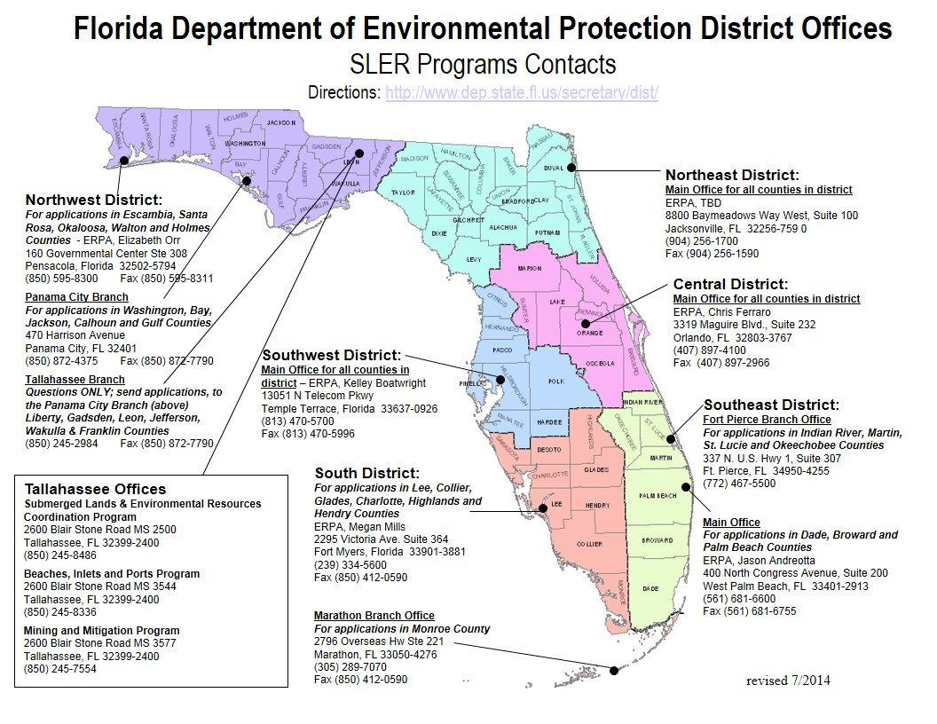

B. Northwest Florida Water Management District Submittal locations and Contacts:
Website: http://www.nwfwmd.state.fl.us/
ePermitting: http://www.nwfwmd.state.fl.us/permits/erp/epermit_home.html
District Headquarters
81 Water Management Drive
Havana, FL 32333
Phone: (850) 539-5999

Tallahassee Field Office (ERP)
3900 Commonwealth Blvd
Tallahassee, FL 32399-3000
Phone: (850) 921-2986

Crestview Field Office
180 East Redstone Avenue
Crestview, Florida 32539
Phone: (850) 683-5044

C. Suwannee River Water Management District Submittal locations and Contacts:
Website: http://www.SRWMD.state.fl.us

Water Supply and Resource Management Department
9225 CR 49
Live Oak, FL 32060
Phone: (386) 362-1001

D. St. Johns River Water Management District Submittal locations and Contacts

Website: http://www.SJRWMD.com For online submittal: http://floridaswater.com/permitting/

District Headquarters
Division of Permit Data Services
4049 Reid Street
Palatka, Florida 32177-2529
-or-
P.O. Box 1429
Palatka, FL 32178-1429
Phone: (386) 329-4500 or 1(800) 451-7106

Jacksonville Service Center
7775 Baymeadows Way, Suite 102
Jacksonville, Florida 32256
Phone: (904) 730-6270 or 1-(800) 852-1563
Maitland Service Center
601 South Lake Destiny Road, Suite 200
Maitland, Florida 32751-7262
Phone: (407) 659-4800

Palm Bay Service Center
525 Community College Pkwy., S. E.
Palm Bay, Florida 32909
Phone: (321) 984-4940

E. Southwest Florida Water Management District Submittal locations and Contacts
Website : http://www.WaterMatters.org For online submittal: http://www.swfwmd.state.fl.us/permits

District Headquarters
2379 Broad Street
Brooksville, FL 34604-6899
Telephone: (352) 796-7211 or
1-800-423-1476

Bartow Service Office
170 Century Boulevard
Bartow, FL 33830-7700
(863) 534-1448

Sarasota Service Office
6750 Fruitville Road
Sarasota, FL 34240-9711
(941) 377-3722

Tampa Service Office
7601 US Hwy. 301
Tampa, FL 33637-6759
Phone: (813) 985-7481

F. South Florida Water Management District Submittal locations and Contacts
Website: www.sfwmd.gov, For online submittal: www.sfwmd.gov/epermitting

Headquarters-Regulation Reception Desk
3301 Gun Club Road
P.O. Box 24680
West Palm Beach, FL 33406-4608
Phone: (561) 682-6736 or 1-800-432-2045

Collier County Service Center/Big Cypress Basin
Poinciana Professional Park
2640 Golden Gate Parkway, Suite 205
Naples, FL 34105
Phone: (239) 263-7615

Lower West Coast Service Center
2301 McGregor Boulevard
Fort Myers, FL 33901
Phone: (239) 338-2929

Okeechobee Service Center
3800 NW 16th Boulevard, Suite A
Okeechobee, FL 34972
Phone: (863) 462-5260

SFWMD Orlando Service Center
1707 Orlando Central Parkway, Suite 200
Orlando, FL 32809
Phone: (407) 858-6100

G. Counties with delegated authority:

1. Broward County:
http://www.broward.org/EnvironmentAndGrowth/Pages/Default.aspx

Broward County Department of Environmental Protection and Growth Management,
Development and Environmental Regulation Division
1 North University Drive, Suite 201
Plantation, FL 33324, (954) 519-1473

Phone: (954) 357-6666

2. Environmental Protection Commission of Hillsborough County:

http://fl-hillsboroughcountyepc.civicplus.com/

Environmental Protection Commission
3629 Queen Palm Dr.
Tampa, FL 33619

Phone: (813) 627-2600

H. Army Corps of Engineers Contacts and Office Locations
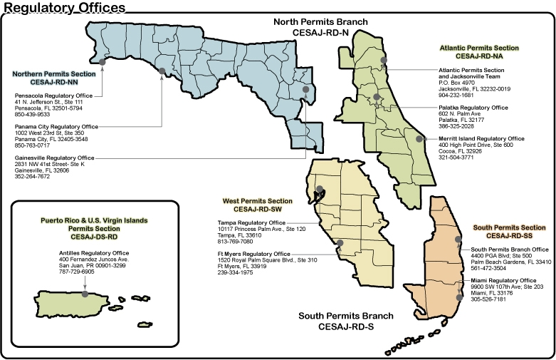

ATTACHMENT 3: APPLICATION FEES

The processing fee required to be submitted with an application, notice, or petition under Chapter 62-330, F.A.C., is specified in the following rules:

Rule 62-4.050, F.A.C. (for a submittal to the Department of Environmental Protection or the Northwest Florida Water Management District)

Rule 40B-1.706, F.A.C. (for a submittal to the Suwannee River Water Management District)

Rule 40C-1.603, F.A.C. (for a submittal to the St. Johns River Water Management District)

Rule 40D-1.607, F.A.C. (for a submittal to the Southwest Florida Water Management District)

Rule 40E-1.607, F.A.C. (for a submittal to the South Florida Water Management District)

For applications, notices, or petitions that are the responsibility of a local government delegated to implement Chapter 62-330, F.A.C., under Section 373.441, F.S., the processing fee shall be submitted to the local government in accordance with the Delegation Agreement between the Department and the local government incorporated by reference in Chapter 62-113, F.A.C.

