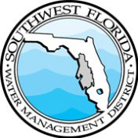 | 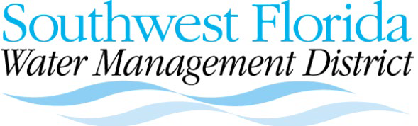 |  | 2379 Broad Street, Brooksville, Florida 34604-6899  (352) 796-7211 or 1-800-423-1476 (FL only)  WaterMatters.org
MEETING NOTICE | Lakes Angelo and Denton Minimum Levels Public Workshop  Thursday, November 13, 2025  5:30 – 6:30 p.m.  Microsoft Teams Virtual Workshop Registration Link:  https://bit.ly/LakesAD  This workshop is virtual and open to the public. Please register ahead of time using the link above.  Agenda  - Welcome and Introductions  T.J. Venning, senior environmental scientist, SWFWMD  - Proposed Minimum Levels for Lakes Angelo and Denton  T.J. Venning, senior environmental scientist, SWFWMD  - Public Comment Period  Visit WaterMatters.org/projects/mfls/lake-angelo-and-lake-denton-minimum-level-reevaluations to view or download the draft reports. The webpage also has information about the lakes and a section for comment submission about the draft plans for District staff review. Public comments will be accepted through November 30, 2025.  For questions regarding the Lake Angelo and Lake Denton proposed minimum levels or the public workshop, please contact T.J. Venning by email at TJ.Venning@WaterMatters.org,
 | Bartow Office  170 Century Boulevard  Bartow, FL 33830-7700  863-534-1448 or 1-800-492-7862 | Sarasota Office  78 Sarasota Center Blvd. Sarasota, FL 34240-9711  941-377-3722 or 1-800-320-3503 |  | Tampa Office  7601 US Highway 301 North  Tampa, FL 33637-6759  813-985-7481 or 1-800-836-0797
 | The Southwest Florida Water Management District (District) does not discriminate on the basis of disability. This nondiscrimination policy involves every aspect of the District’s functions, including access to and participation in the District’s programs, services and activities. Anyone requiring reasonable accommodation, or who would like information as to the existence and location of accessible services, activities, and facilities, as provided for in the Americans with Disabilities Act, should contact the Human Resources Office Chief, at 2379 Broad St., Brooksville, FL 34604-6899; telephone (352) 796-7211 or 1-800-423-1476 (FL only); or email ADACoordinator@WaterMatters.org. If you are hearing or speech impaired, please contact the agency using the Florida Relay Service, 1-800-955-8771 (TDD) or 1-800-955-8770 (Voice). If requested, appropriate auxiliary aids and services will be provided at any public meeting, forum, or event of the District. In the event of a complaint, please follow the grievance procedure located at WaterMatters.org/ADA.

