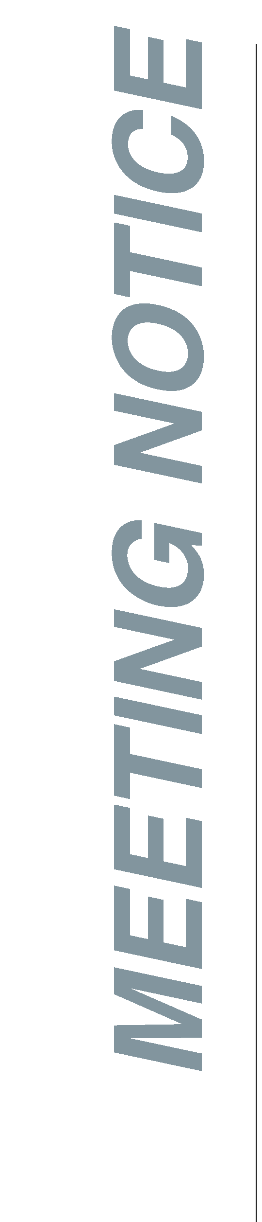
AGENDA

Southwest Florida Water Management District
Brant Lake Minimum and Guidance Levels Public Workshop

Thursday, August 23, 2018
5:30 to 7:00 p.m.

Lutz Community Center
98 1st Ave NW
Lutz, Florida 33548

- Welcome and introductions
- Joel Brown, Government Affairs Regional Manager, SWFWMD*

2. Proposed minimum and guidance levels presentation
- David Carr, Staff Environmental Scientist, SWFWMD*
- Cortney Cameron, Hydrogeologist, SWFWMD*

3. Open discussion and public input
- Facilitated by David Carr

For questions or to submit additional public comment on the proposed minimum and guidance levels for Brant Lake, please use the comment sheet provided during the workshop or contact David Carr by email at David.Carr@watermatters.org, by telephone at 1-800-423-1476, extension 4246, or by mail at the address listed at the top of this agenda.

*SWFWMD = Southwest Florida Water Management District

