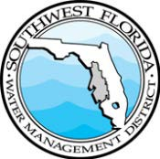
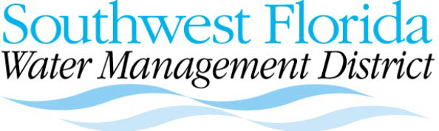
2379 Broad Street, Brooksville, Florida 34604-6899
(352) 796-7211 or 1-800-423-1476 (FL only)
WaterMatters.org

An Equal Opportunity Employer
MEETING NOTICE
The Southwest Florida Water Management District (District) does not discriminate on the basis of disability. This nondiscrimination policy involves every aspect of the District’s functions, including access to and participation in the District’s programs, services and activities. Anyone requiring reasonable accommodation, or who would like information as to the existence and location of accessible services, activities, and facilities, as provided for in the Americans with Disabilities Act, should contact the Human Resources Office Chief, at 2379 Broad St., Brooksville, FL 34604-6899; telephone (352) 796-7211 or 1-800-423-1476 (FL only); or email ADACoordinator@WaterMatters.org. If you are hearing or speech impaired, please contact the agency using the Florida Relay Service, 1-800-955-8771 (TDD) or 1-800-955-8770 (Voice). If requested, appropriate auxiliary aids and services will be provided at any public meeting, forum, or event of the District. In the event of a complaint, please follow the grievance procedure located at WaterMatters.org/ADA.

AGENDA

Southwest Florida Water Management District

Public Workshop
Draft Springs Surface Water Improvement and Management (SWIM) Plan Quantifiable Objective Refinements

Wednesday, Oct. 18, 2023
2 p.m.

Welcome/introductions facilitated by Vivianna Bendixson, SWIM manager

- Springs SWIM Plan Quantifiable Objective Refinements presented by Madison Trowbridge, springs scientist

- Facilitated Public Comment

Teams Registration Link:
https://bit.ly/SWIMPlans

Registration is required. Click on the link above to register for the meeting with Teams. Once you complete registration, you will receive an email with instructions and a link to join the meeting.

For questions or to submit additional public comment on the Springs Surface Water Improvement and Management Plan (Plan) Quantifiable Objective Refinements, please use the Web Board at WaterMatters.org/SWIM. The Web Board will be available for public comment through 5:00 p.m., Eastern Daylight Time, Wednesday November 1, 2023. For those lacking access to the internet, a copy of the quantifiable objective refinements to the Surface Water Improvement and Management (SWIM) Plans may be requested by calling ((813) 336-1078. Comments may be submitted in writing by mail to SWIM Program, 2379 Broad Street, Brooksville, Florida 34604-6899.

Bartow Office
170 Century Boulevard
Bartow, FL 33830-7700
863-534-1448 or 1-800-492-7862
Sarasota Office
78 Sarasota Center Boulevard Sarasota, FL 34240-9711
941-377-3722 or 1-800-320-3503
Tampa Office
7601 US Highway 301 North
Tampa, FL 33637-6759
813-985-7481 or 1-800-836-0797

