SUBMIT OFFERS TO:

LAND RESOURCES, BUILDING 6
SOUTHWEST FLORIDA WATER MANAGEMENT DISTRICT
2379 BROAD STREET (U.S. HIGHWAY 41 SOUTH)
BROOKSVILLE, FLORIDA 34604-6899
TELEPHONE: (352) 796-7211 Ext. 4534; FAX: (352) 754-3494
Email: Land@WaterMatters.org
July 31, 2020

INFORMATION FOR PROSPECTIVE LESSEES
REQUEST FOR OFFERS TO LEASE PROPERTY (RFO) 20-05
LAKE HANCOCK HIDDEN LAKE CATTLE LEASE, SWF PARCEL NO. 20-503-255X

INTRODUCTION

The District requests offers to lease property for cattle grazing and haying purposes only. Please review the requirements and specifications.

VOLUNTARY SITE VISIT

Tuesday, August 11, 2020

Above site visits start at 11:00 a.m. Eastern time
Lake Hancock Hidden Lake Cattle Lease
Bartow, Florida

Access to this property is from Fox Hunt Drive
It is recommended that attendees have a high clearance 4 x 4 vehicle.

From Brooksville: Take Highway 700 east to Highway 301. Take Highway 301 south to U.S. Highway 98. Take U.S. Highway 98 south through Lakeland to Winter Lake Road (traffic light just south of the Polk Parkway.) Turn left on Winter Lake Road. Take Winter Lake Road east to Thornhill Road. Turn right on Thornhill Road and travel approximately 2.8 miles to Moonlite Pass on right side of Thornhill Road. Turn right on Moonlite Pass. Turn left on Old Thornhill Road. Turn right on Fox Hunt Drive. Drive to the west end (cul-de-sac) of Fox Hunt Drive.

From Lakeland: Take U.S. Highway 98 south through Lakeland to Winter Lake Road (traffic light just south of the Polk Parkway.) Turn left on Winter Lake Road. Take Winter Lake Road east to Thornhill Road. Turn right on Thornhill Road and travel approximately 2.8 miles to Moonlite Pass on right side of Thornhill Road. Turn right on Moonlite Pass. Turn left on Old Thornhill Road. Turn right on Fox Hunt Drive. Drive to the west end (cul-de-sac) of Fox Hunt Drive.

The District recommends that all interested parties attend the site visit. The purpose of a site visit is to provide interested parties an opportunity to view the site and present questions to staff.

PART I – GENERAL CONDITIONS

- INTERNET AVAILABILITY. District Requests for Offers (RFO), changes, delays, addenda, and questions and answers are available for review and download at www.WaterMatters.org/land-lease. Persons/firms receiving this RFO from the District’s Internet website are responsible to recheck the website for any changes or addenda.

- AMERICANS WITH DISABILITIES ACT (ADA). The District does not discriminate on the basis of disability. This nondiscrimination policy involves every aspect of the District’s functions, including access to and participation in the District’s programs and activities. Anyone requiring reasonable accommodation as provided for in the Americans with Disabilities Act should contact the District’s Human Resources Bureau Chief, 2379 Broad Street, Brooksville, Florida 34604-6899; telephone (352) 796-7211, ext. 4702 or 1-800-423-1476 (FL only), ext. 4702; TDD (FL only) 1-800-231-6103; or email to ADACoordinator@WaterMatters.org.

- CORRESPONDENCE. Unless otherwise notified in writing, correspondence relating to this RFO will be sent to the District at the address set forth in the heading of this RFO, and to the Respondent at the address stated on Attachment 1, Offer Response Form.

- QUESTIONS. All questions should be submitted in writing to Land@WaterMatters.org, the address as referenced in Paragraph 1.3, Correspondence, or faxed, followed by a confirmation, to Land Resources at 352-754-3494 for receipt no later than ten (10) working days prior to the offer opening. Inquiries must reference the date of offer opening, and RFO title and number. Respondents are responsible to check the website listed in Paragraph 1.1, Internet Availability for the District’s responses to the questions presented.

- DEVELOPMENT COST. Neither the District nor its representative will be liable for any expenses incurred in connection with preparation of an offer prepared in response to this RFO. All offers should be prepared simply and economically, providing a straightforward and concise description of the Respondent’s ability to meet the requirements of this RFO.

- DELAYS, CHANGES AND ADDENDA. The District reserves the right to delay scheduled RFO due dates if determined to be in the best interest of the District. Any changes, delays, addenda or questions and answers related to this RFO issued by the District will be posted to the website identified in Paragraph 1.1, Internet Availability. No interpretation of the meaning of the specifications or other aspects of this RFO, nor correction of any apparent ambiguity, inconsistency or error herein, will be made to any Respondent orally. Respondents are advised that no other sources are authorized to give information concerning, explaining, or interpreting this RFO. Any information obtained from an officer, agent or employee of the District or any other person will not affect Respondent’s risks or obligations or relieve it from fulfilling any and all conditions of this RFO.

- CONFLICT OF INTEREST. The award hereunder is subject to the provisions of Chapter 112, Part III, F.S., as amended, governing conflicts of interest. All Respondents must disclose with their offer the name of any officer, director, or agent who is also a public employee. Further, all Respondents must disclose the name of any public employee who owns, directly or indirectly, an interest of five percent (5%) or more in the Respondent's firm or any of its branches.

The Respondent hereby agrees that, at the time of execution of a lease agreement, the Respondent will not be involved in any matters which adversely affect any interest or position of the District, and that the Respondent has no relationship with any third party relating to any matters which adversely affect any interest or position of the District. The Respondent will not accept during the term of the agreement, or any renewal thereof, any retainer or employment from a third party whose interests appear to be conflicting or inconsistent with those of the District.

- CANCELLATION/REJECTION OF OFFERS. The District reserves the right to cancel the RFO prior to offer opening date and time set forth in Paragraph 1.12 and will give notice of cancellation by posting a notice on the District's website. Notice of cancellation or rejection will be posted on the District's website and sent to all Respondents. Acceptance of the offer made by the successful Respondent is subject to District Governing Board approval and no lease agreement shall be formed as a result of this RFO until the Governing Board and successful Respondent (Lessee) execute a lease agreement. Respondents are responsible for all costs associated with the preparation of their offers.

- OFFER WITHDRAWAL. Offers may be withdrawn prior to the date and time set forth in Paragraph 1.12 below if the District receives a signed written request to withdraw an offer from an authorized representative of the Respondent. The District, in its sole discretion, may accept the next highest offer received or reject all offers and re-notice the solicitation.

- OFFER SIGNATURE AND FORM. An authorized representative of the Respondent must manually sign the attached Offer Response Form where indicated and signed in non-erasable ink in the spaces provided. All corrections made to the offer by the Respondent must be initialed. All offers must be submitted complete as outlined in Part III, Offer Response.

- REFERENCES. The Respondent must provide at least three (3) references who can verify qualifications and past performance on projects of similar scope, as may be more specifically described in Attachment 2. The District will contact the references provided to verify qualifications of the Respondent.

1.11.1 Offers must contain documentation demonstrating a minimum of two (2) years of experience in managing a cattle grazing operation of 100 acres or greater. Documentation should include any experience of managing a cattle grazing operation on public lands. The District may request additional documentation if, in its sole discretion, such additional information is necessary to evaluate the ability of the Respondent to perform.

- OFFER RECEIPT AND OPENING. Each offer must be placed in a sealed envelope with “RFO 20-05 Lake Hancock Hidden Lake Cattle Lease, SWF Parcel No. 20-503-255X” on the face of the envelope. If offers are sent via Express Mail, all documents must be placed in a separate sealed envelope, properly identified with the above referenced information, within the Express Mail envelope, and the specific information stated above must be on the outer envelope. One (1) signed original, and two (2) copies of all documents discussed below within Part III, Offer Response must be received by the District's Land Resources Office (BKV-6-OPS), Building 6, at the Southwest Florida Water Management District, 2379 Broad Street (U.S. Hwy. 41 South), Brooksville, Florida 34604-6899, on or before Wednesday, July 19, 2020 at 2:00 p.m. Offers that are not received in a timely manner by this specific office will not be accepted. All visitors must report to the lobby of Building 4 to sign in and be issued a visitor’s badge. Offers will be opened immediately after this date and time.

- SELECTION. The District will enter into a lease agreement with the Respondent who has submitted the highest per acre price and has the capability in all respects to fully perform the lease requirements, (hereinafter “successful Respondent”). If there is a tie in per acre price, the offer of the Respondent determined to be the most responsible considering reference responses, years of experience in managing cattle grazing operations on public lands, and any other relevant information as determined by the District, in its sole discretion, will be presented to the District Governing Board for consideration at its meeting on Tuesday, September 22, 2020. Please refer to the District’s website for the Governing Board meeting information at www.WaterMatters.org/calendar/meetingfiles. Acceptance of the offer made by the successful Respondent is subject to Governing Board approval and no lease shall be formed or effective as a result of this RFO until the Governing Board and the successful Respondent execute a lease agreement.
- ASSIGNMENT OF LEASE. No offer, after acceptance by the District, shall be assigned by the successful Respondent, without the prior written consent of the District.

- EXECUTION OF LEASE. By submitting an offer, Respondent agrees to all the terms and conditions of this RFO and those included in the Lease Agreement attached as Attachment 3. The terms of the Lease Agreement are non-negotiable. The Lease Agreement must be executed by the successful Respondent prior to its submittal to the District Governing Board for execution on Tuesday, September 22, 2020.

- LAW COMPLIANCE. The Respondent will abide by all applicable federal, state and local laws, rules, regulations and guidelines (including but not limited to the Americans with Disabilities Act) relative to performance under this RFO. The Respondent will not discriminate against any employee or applicant for employment because of race, color, religion, sex, handicap, disability, marital status or national origin. Respondent will obtain and maintain all permits and licenses necessary for its performance under this RFO.

PART II – TERMS AND PROPERTY SPECIFICATIONS

The following provides fundamental information of the Property and is provided to assist the Respondent in preparing its offer. PLEASE NOTE: The following provisions are not exhaustive of all the requirements under the Lease Agreement. The Respondent should read the entire Lease Agreement prior to submitting an offer.

- DESCRIPTION. The Lake Hancock Hidden Lake tract (Property) to be leased is approximately 503 acres located in central Polk County on the east side of Lake Hancock and west of Thornhill Road (Sections 4, 5 and 9, Township 29 South, Range 25 East and Section 33, Township 29 South, Range 25 East). The Property consists of approximately 307± acres of fair condition Bahia grass (Paspalum notatum) pasture recently managed as a cow-calf operation. The other plant communities on the Property include 2± acres of mesic hardwood forest and 2013± acres of herbaceous/open water. (See Attachment 4 for general location map) The Property will be leased for cattle grazing (cow-calf) and haying purposes only.

- STOCKING RATE. The estimated maximum stocking rate for the property is 50 animal units. The Lessee may stock any number of animal units below the maximum without adjustment to the annual rent payment. The stocking rate may be increased upon favorable evaluation and written approval by the District. An increase in the Stocking Rate will be effective on the next date rent is following the District’s approval of the increase. The amount of rent due will be increased by an amount equal to the increase in the number of Animal Units approved by the District.

- TERM OF LEASE. The term of the lease is five (5) years, commencing on September 22, 2020, with an option to request renewal for an additional term of five (5) years.

- FENCE AND IMPROVEMENTS. The majority of the Property’s perimeter is fenced. Interior fencing and gates needed to support cattle grazing operations may need to be installed or repaired by the Lessee prior to the placement of cattle on the Property. The Lessee must obtain prior written approval from the District before constructing any additional interior fences on the Property. Unless other type of fencing is approved by the District, new fences will be constructed of four (4) strands of barbed wire, attached to pressure treated or iron fence posts. Post spacing will not exceed twenty (20) feet. All fences remain the property of the District. The cost of construction, installation and maintenance of interior fencing and gates will be the responsibility of the Lessee.

  - 2.4.1 Cattle Pens. There are no cattle or working pens on the Property. The Lessee must use portable pens or construct pens. The Lessee is solely responsible for expenses incurred for use or construction of cattle pens.

- WATER. Water sources on the Property are the open water areas within the tract. Lessee will be responsible for establishing a dependable water source on the Property if needed. Lessee must obtain all necessary permits and authorizations prior to establishing any water source on the Property. The Lessee is solely responsible for expenses incurred for establishing water sources.

- PRESCRIBED BURNS. The Lessee will be responsible for planning and conducting prescribed burns on the Property in accordance with the terms of the lease.

- CONTROL OF TROPICAL SODA APPLE. The Lessee is solely responsible for maintaining effective control of tropical soda apple using the Best Management Practices established by the University of Florida, Institute of Food and Agricultural Sciences Publication Number SS-AGR-77, and updates thereto (Attachment 5).

- FERAL HOGS. The Lessee shall trap or shoot feral hogs on the Property and maintain a record of all feral hog control activities conducted by Lessee. All hogs trapped on the Property must be euthanized in a humane manner and may not be relocated or released. The Lessee will submit the record of all feral hog control activities annually by October 1.

- HAYING: Haying is allowed on the Property in accordance with the terms of the lease.

PART III - OFFER RESPONSE

- OFFER RESPONSE. A cost per acre per year must be proposed by Respondents. The annual rental amount resulting from this RFO is due on September 22, 2020, and all future payments will be due on the anniversary date of the lease.

ATTACHMENT 1

OFFER RESPONSE FORM
FOR
RFO 20-05 LAKE HANCOCK HIDDEN LAKE CATTLE LEASE, SWF PARCEL NO. 20-503-255X

The undersigned agrees to lease District-owned land for cattle grazing and haying purposes only in accordance with the terms and conditions of this Request for Offers and the Lease Agreement for the amount of:

$_________ per Acre X 503 Acres = $______________Total Offer Amount

TOTAL OFFER AMOUNT IN WORDS (Type or Clearly Print):

ATTACHMENT 1 (Cont.)

OFFER RESPONSE FORM
FOR
RFO 20-05 LAKE HANCOCK HIDDEN LAKE CATTLE LEASE, SWF PARCEL NO. 20-503-255X

The undersigned Respondent has carefully read this Request for Offers to Lease Property (RFO) and its provisions, terms and conditions covering the management of Green Swamp Wilderness Preserve and the Lease Agreement, and fully understands the requirements and conditions. Respondent certifies that this offer is made without prior understanding, agreement, or connection with any corporation, firm, entity, or person submitting an offer for the same property (unless otherwise specifically noted), and is in all respects fair and without collusion or fraud. Respondent agrees to be bound by all the terms and conditions of this RFO and the Lease Agreement and certifies that the person signing this offer is authorized to bind the Respondent.

The undersigned Respondent certifies that the Attachment 2, Respondent Qualifications and References, provided is true and correct to the best of his/her knowledge.

The undersigned Respondent has also carefully read any Addenda and Questions and Answers issued for this RFO. (Addenda and Questions and Answers are available at the District’s website, www.WaterMatters.org/land-lease. Each Respondent is responsible for reviewing these documents.)

___________________________________________________________________________________________
Respondent Name (Company Name as Contained on Corporate Seal)

___________________________________________________________________________________________
Mailing Address City State Zip Code

___________________________________________________________________________________________
Physical Address City State Zip Code

___________________________________________________________________________________________
Telephone Number Fax Number Email Address

___________________________________________________________________________________________
Authorized Signature Date Print/Type Name and Title

ATTACHMENT 2

RESPONDENT QUALIFICATIONS AND REFERENCES
FOR
RFO 20-05 LAKE HANCOCK HIDDEN LAKE CATTLE LEASE, SWF PARCEL NO. 20-503-255X

- REFERENCES FOR RESPONDENT:

Respondent must provide a minimum of three (3) references who can verify Respondent’s qualifications and past performance on projects similar in scope and nature to this RFO. References must demonstrate Respondent’s experience and expertise in successfully completing projects similar in scope and nature to this RFO. Specific projects must be provided.

Required format for references is provided in this attachment. References must be individuals that can be readily contacted and have first-hand knowledge of the Respondent’s performance on the specific project performed by the Respondent.
REFERENCE FORMAT

1. Business Name:
Contact Person:
Address:
Phone No.:
Term and Service Performed:

2. Business Name:
Contact Person:
Address:
Phone No.:
Term and Service Performed:

3. Business Name:
Contact Person:
Address:
Phone No.:
Term and Service Performed:

ATTACHMENT 3
FOR
RFO 20-05 LAKE HANCOCK HIDDEN LAKE CATTLE LEASE, SWF PARCEL NO. 20-503-255X

AGREEMENT NO. 20-503-255X

CATTLE GRAZING LEASE AGREEMENT

THIS LEASE, made this ______ day of ___________________, 202_, by and between the SOUTHWEST FLORIDA WATER MANAGEMENT DISTRICT, having an address of 2379 Broad Street, Brooksville, Florida 34604-6899, hereinafter called the “LESSOR”, and ___________________________________________________________ having an address of __________________________________, Florida_________, hereinafter called the “LESSEE.”

WITNESSETH:

The LESSOR, for and in consideration of the rents, covenants and agreements hereinafter contained, does hereby lease to the LESSEE, all that certain property located in Polk County Florida, hereinafter referred to as the “PROPERTY”, depicted in Exhibit “A”, and described in Exhibit “B” attached hereto, subject to the following terms and conditions:

1. RENT: The LESSEE agrees to pay the LESSOR an annual rental amount of _________________________________________________________________________ ($__________) for 503 acres per year, or at the rate of $______ per acre per year. The first payment is due upon execution of this Lease and subsequent payments will be due annually on the anniversary of the execution date of this Lease (“Anniversary Date”).

2. TERM: This Lease will be for a term of five (5) years commencing on the date of execution of this Lease, unless otherwise renewed by the LESSOR pursuant to the terms and conditions set forth in Paragraph 21. If this Lease is renewed then the term will commence on the date of execution by the LESSOR.

3. USE: The LESSEE may use the PROPERTY for cattle grazing and haying purposes only.

4. STOCKING RATE: An Animal Unit is one (1) bull or one (1) cow with or without one (1) un-weaned calf. The maximum Stocking Rate for the PROPERTY is 50 Animal Units. The LESSEE may stock any number of Animal Units at or below the maximum stocking rate stated without an adjustment to the annual rent payment. Upon written request from the LESSEE, the stocking rate may be increased upon a favorable evaluation and written approval by the LESSOR. The LESSOR reserves the right to inspect the condition of the PROPERTY at any time during this Lease and adjust the Stocking Rate due to the PROPERTY being overgrazed based on this inspection and/or forage production analysis. The amount of rent due will be increased or decreased by an amount equal to the percentage change in the number of Animal Units approved by the LESSOR. The change in the Stocking Rate will be effective on the next date rent is due to the LESSOR following the LESSOR’S approval of the increase.

5. ASSIGNMENT: The LESSEE may not assign this Lease, or any interest herein, without the prior written approval of the LESSOR. Neither this Lease nor any interest of the LESSEE herein is assignable or transferable in proceedings by or against the LESSEE in execution, bankruptcy, or insolvency, or in any other manner by operation of law. Any assignment or change of control made either in whole or in part without the prior written approval of the LESSOR shall be void and without legal effect. Any purported assignment or change of control in violation of this Paragraph will constitute a material breach of this Lease for which the LESSOR may immediately terminate this Lease.

6. SUBLEASES: The LESSEE will not sublease the PROPERTY, unless the LESSEE obtains prior written approval of the terms and conditions of the sublease from the LESSOR. Any sublease not approved in writing by the LESSOR will be void and without legal effect. Any purported sublease in violation of this Paragraph will constitute a material breach of this Lease for which the LESSOR may immediately terminate this Lease. The LESSOR’S approval of a particular sublease does not constitute a waiver of the right to withhold approval of subsequent subleases.

7. PRESCRIBED BURNS:

(a) The LESSEE will be responsible for planning and conducting prescribed burns on the PROPERTY. All burning on the PROPERTY must be conducted in accordance with Section 590.125, Florida Statutes (F.S.). As required by subsection 590.125(3)(b), F.S., a certified prescribed burn manager must be on site with a copy of the prescription from the time of ignition until the burn is completed. Prescribed burns conducted on the PROPERTY by the LESSEE that are not in compliance with the conditions described herein, will be considered a material breach of this Lease for which the LESSOR may immediately terminate this Lease.

(b) The LESSEE may not conduct a prescribed burn on the PROPERTY or any part thereof without first submitting a written burn plan to the LESSOR that contains all pertinent information, i.e., area to be burned, season of burn, frequency of burns, etc., in a format approved by the LESSOR, for review and approval by October 1 of each year of this Lease. The LESSEE must obtain authorization from the Florida Forest Service of the Department of Agriculture and Consumer Services and the County, if applicable, prior to conducting a prescribed burn on the PROPERTY. The LESSEE'S responsibility to conduct prescribed burns on the PROPERTY will not prevent the LESSOR from conducting prescribed burns on the PROPERTY when necessary for other land management purposes.

(c) The LESSEE agrees to indemnify, defend and hold harmless the LESSOR, its officers, agents and employees from any and all damage or injury that may be caused by fire or smoke resulting from burning conducted on the PROPERTY by the LESSEE. Pursuant to subsection 590.125(3)(c), F.S., no property owner or his or her agent is liable pursuant to Section 590.13, F.S., for damage or injury caused by the fire or resulting smoke for burns conducted in accordance with subsection 590.125(3)(b), F.S., unless gross negligence is proven. Any and all damages to the PROPERTY or improvements to the PROPERTY caused by fire or smoke resulting from burning conducted on the PROPERTY by the LESSEE must be repaired by the LESSEE at its sole expense. This Paragraph shall survive the expiration or termination of this Lease.

(d) The LESSEE will disc the existing firelanes identified on Exhibit “C,” at least annually and more frequently if necessary, to protect the PROPERTY from damage or destruction by wildfires and to ensure that prescribed burns are conducted safely. Discing must be completed between December and March of each year of this Lease. Firelanes will be maintained at a maximum width of twelve (12) feet. The LESSEE may not create any new firelanes without the prior written approval of the LESSOR.

8. FENCING AND IMPROVEMENTS:

(a) Unless another type of fencing is approved by the District, new fences will be constructed of four (4) strands of barbed wire, attached to pressure treated or iron fence posts. Post spacing will not exceed twenty (20) feet. All fences remain the property of the LESSOR.

(b) The LESSEE will maintain all fences and gates in good condition during the term of this Lease. In the event an existing fence on the PROPERTY is damaged or inadequate, the LESSEE will take immediate action to repair it. Fences that must be repaired or replaced will be constructed in the same manner as new fences.

(c) The LESSEE must obtain prior written approval from the LESSOR before constructing any additional interior fences upon the PROPERTY. The LESSEE will maintain in good repair, any existing improvements upon the PROPERTY, e.g. troughs, sheds, and other structures, or any improvements that may be placed upon the PROPERTY during the term of this Lease. The LESSEE may not make improvements to the PROPERTY without the prior written approval of the LESSOR. All permanent improvements will remain the property of the LESSOR, e.g. well(s) for cattle watering purposes.

(d) The LESSEE must use portable cattle pens or construct pens. The LESSEE is solely responsible for expenses incurred for use or construction of cattle pens.

(e) The LESSEE will be responsible for establishing a dependable water source on the PROPERTY if needed by the LESSEE. The LESSEE must obtain all necessary permits and authorizations prior to establishing any water source on the PROPERTY. The LESSEE is solely responsible for expenses incurred for establishing water sources.

9. IDENTIFICATION: All cattle must bear identification, e.g., ear tags, tattoos, brands, etc., readily traceable to the LESSEE before their release on the PROPERTY.

10. HUNTING: With the exception of the activities allowed pursuant to paragraph 12 (c), hunting on the leased property is prohibited.

11. PUBLIC USE: The LESSOR reserves the right to use the PROPERTY, in whole or part, for activities, including but not limited to passive recreation.

12. GENERAL OPERATION AND MANAGEMENT: The LESSEE will take appropriate measures to prevent overgrazing, pasture degradation and other environmental impacts to the PROPERTY. Such measures will include but are not limited to the following:

(a) The LESSEE will conduct all activities in accordance with all applicable rules and regulations. The LESSEE further agrees, when practicable, to conduct all activities in accordance with the most recent Water Quality Best Management Practices (BMPs), established by the Florida Department of Agriculture and Consumer Services, Office of Agricultural Water Policy (FDACS-OAWP). The FDACS-QAWP Water Quality/Quantity Best Management Practices Manual is available from The FDACS-OWAP at:

http://freshfromflorida.s3.amazonaws.com/Bmp_FloridaCowCalf2008.pdf
or:

FDACS-OAWP
1203 Governor’s Sq. Blvd.
Suite 200
Tallahassee. FL 32301

Prior to conducting activities on the PROPERTY, the LESSEE will demonstrate its intent to implement practicable BMPs by signing the following FDACS-QAWP Notice of Intent to Implement Water Quality BMPs for Florida Cow/Calf Operations form, found within the FDACS-QAWP Water Quality/Quantity Best Management Practices Manual, and submitting them to FDACS-OAWP, with copies to the LESSOR.

(b) The LESSOR is required to manage invasive plant species on the PROPERTY consistent with Florida Statutes. The LESSEE shall not impede the LESSOR’S efforts to control invasive species on the PROPERTY. The LESSEE shall be solely responsible for maintaining effective control of tropical soda apple (TSA) using the Best Management Practices described in the University of Florida, Institute of Food and Agricultural Sciences Publication Number SS-AGR-77, and updates thereto at:

http://edis.ifas.ufl.edu/uw097

The LESSOR will ensure that there is less than 5% coverage of TSA on the PROPERTY at the time this Lease is executed. The LESSOR and the LESSEE will conduct an inspection of the PROPERTY following execution of this Lease, to document that TSA is under satisfactory control. The LESSEE’S failure to maintain acceptable control of TSA will constitute a material breach of this Lease for which the LESSOR may either immediately terminate this Lease or treat the PROPERTY. If the LESSOR chooses to treat the PROPERTY, the LESSEE is solely responsible for the cost of such treatment by the LESSOR and agrees to reimburse the LESSOR the full amount of the cost upon the LESSOR’S written request. The LESSEE’S failure to reimburse the LESSOR within 5 days of receipt of LESSOR’S written request will constitute a material breach of this Lease for which the LESSOR may immediately terminate this Lease. If the LESSEE uses fertilizer, hay, seed or other planting materials on the PROPERTY that originated off-site, the LESSEE must make every practicable effort to ensure that such materials are free of invasive plant seeds and other propagules before using.

(c) The LESSEE shall trap or shoot feral hogs on the PROPERTY and maintain a record of all feral hog control activities conducted by the LESSEE. All hogs trapped on the PROPERTY must be euthanized in a humane manner and may not be relocated or released. The LESSEE will submit the record of all feral hog control activities to the LESSOR by October 1 of each year of this lease.

13. PASTURE CONDITIONS: The LESSEE will take appropriate measures to prevent overgrazing and pasture degradation that include, but are not limited to the following:

- The maintenance of existing improved pastures by rotating, fertilizing, mowing, discing, dragging, and removing invasive plant species.

- Fertilizing and liming the improved pastures when practicable, in accordance with the recommendations of the Natural Resource Conservation Service (NRCS).

- The indirect rotation of cattle through the strategic placement and periodic movement of feed troughs, mineral blocks, water troughs, and molasses tanks. The LESSEE must use a rotational grazing system that will prevent overgrazing of any one pasture.

- To ensure that the quality of the improved pasture is maintained or enhanced, the LESSEE agrees to mow, disc, or drag the pastures at least once a year, or more frequently if required.

14. HAYING: Haying is allowed on the PROPERTY. The LESSEE will conduct haying activities in a manner that will not damage or strip the pasture(s) of desirable grasses. During haying operations, the LESSEE will maintain a two-inch stubble height. If the LESSEE purchases hay, seed or other planting materials off-site, the LESSEE agrees to make every practicable effort to ensure that such materials are free of invasive plant species.

15. QUARANTINE: The LESSEE must quarantine all cattle for seven (7) days prior to releasing them on the PROPERTY. The LESSEE must ensure that all cattle are free of exotic seed prior to releasing them on the PROPERTY.

16. WORKS OF THE DISTRICT: The LESSOR reserves the right to enter upon the PROPERTY, at such times and places as the LESSOR may deem necessary, for the purposes of inspecting the PROPERTY, or constructing roads, canals or ditches, infrastructure and amenities related to public recreation, or other projects, and for any matter pertaining to water management or land management activities.

17. SALE OF PROPERTY: If the LESSOR sells the PROPERTY during the term of this Lease, the LESSOR, in its sole discretion, may either assign this Lease in whole to the new owner without the LESSEE’S consent, or terminate this Lease upon six (6) months prior written notice to the LESSEE.

18. PERSONNEL AND VEHICLES: Only personnel and vehicles utilized or authorized by the LESSEE for use in its cattle grazing and haying operations are allowed on the PROPERTY.

19. PROTECTION: The LESSEE will regularly inspect the PROPERTY to detect and prevent wildfires, trespasses and vandalism on the PROPERTY. Additionally, the LESSEE will regularly inspect the PROPERTY for downed or damaged fence, open gates and cattle that may have strayed from the PROPERTY. The LESSEE must immediately notify the appropriate governmental agencies and the LESSOR upon the discovery of any wildfire, trespass, or vandalism. The LESSEE is responsible for repairing damaged fences, and taking appropriate measures to immediately return stray cattle to the PROPERTY.

20. INDEMNIFICATION: The LESSEE agrees to indemnify and hold harmless the LESSOR and all the LESSOR’S agents, employees and officers from and against all liabilities, claims, damages, expenses or actions, either at law or in equity, including attorneys’ fees and costs and attorneys’ fees and costs on appeal, caused or incurred, in whole or in part, as a result of any act or omission by the LESSEE, its agents, employees, subcontractors, assigns, heirs or anyone for whose acts or omissions any of these persons or entities may be liable during the LESSEE’S use of the PROPERTY and performance under this Lease. This Paragraph will survive the expiration or termination of this Lease.

21. LESSOR’S OPTION TO RENEW:

(a) The LESSOR, at its sole discretion, may offer to renew this Lease for one additional five-year term under such terms and conditions as may be established by the LESSOR. The LESSOR will notify the LESSEE if it intends to offer to renew this Lease in accordance with this Paragraph prior to soliciting offers on the PROPERTY. If the LESSOR does not notify the LESSEE of its intent to offer to renew this Lease, then this Lease will expire at the end of the term.

(b) Approximately six months prior to the expiration of this Lease, the LESSOR may request competitive offers on the PROPERTY. If the LESSOR requests offers under this subparagraph, this Lease may be renewed for one additional five year term under such terms and conditions as may be established by the LESSOR, if the LESSEE meets the following conditions:

- The LESSEE submits a responsive offer;
- If the LESSEE’S offer is not the highest offer received, the LESSEE agrees to exceed the highest offer received during the offer process by five percent (5%);
- The LESSEE has successfully performed under this Lease;
- The LESSEE agrees to any modifications to the lease terms and conditions as determined by the LESSOR;
- The LESSEE accepts the renewal terms and conditions within ten (10) business days from receipt of the LESSOR’S offer to renew by delivering notice of the LESSEE’S acceptance to the LESSOR by hand delivery or certified mail. If by certified mail, date of delivery shall be the date the notice is placed in mail.
- The LESSEE’S failure to deliver written acceptance of the LESSOR’S offer to renew within the time specified will be deemed a rejection of the terms by the LESSEE.

Upon receipt of the LESSEE’S timely written acceptance of the LESSOR’S offer to renew, the LESSOR and the LESSEE will execute a written amendment to this Lease to record the renewal and conditions thereto, if any.

22. INSURANCE: The LESSEE must maintain during the full term of this Lease, and at its sole expense, insurance in the following kinds and amounts or limits with a company or companies authorized to do business in the State of Florida. This Lease will not be effective until the LESSOR has received an acceptable certificate of insurance showing evidence of such coverage. Certificates of insurance must reference this Lease.

(a) Liability insurance on forms no more restrictive than the latest edition of the Commercial General Liability Policy (GC 00 01) of the Insurance Services Office without restrictive endorsements, or equivalent, with the following minimum limits and coverage:

Minimum Limits $1,000,000 per occurrence

(b) Vehicle liability insurance, including owner, non-owned and hired autos with the following minimum limits and coverage:

Bodily Injury Liability Per Person $100,000
Bodily Injury Liability Per Occurrence $300,000
Property Damage Liability $100,000
-or-
Combined Single Limit $500,000

(c) The LESSOR and its employees, agents, and officers must be named as additional insured on the general liability policy to the extent of the LESSOR'S interests arising from this Lease.

(d) The LESSEE must obtain certificates of insurance from any subcontractor otherwise the LESSEE must provide evidence satisfactory to the LESSOR that coverage is afforded to the subcontractor by the LESSEE’S insurance policies.

(e) The LESSEE must notify the LESSOR in writing of the cancellation or material change to any insurance coverage required by this Paragraph. Such notification must be provided to the LESSOR within five (5) business days of the LESSEE’S notice of such cancellation or change from its insurance carrier.

23. TAXES: If any ad valorem taxes, intangible property taxes, personal property taxes, or other liens or taxes of any kind are assessed or levied lawfully on the PROPERTY, based on the LESSEE'S use of the PROPERTY during the term of this Lease, the LESSEE agrees to pay all such taxes, assessments or liens, within thirty (30) days after receiving written notice from the LESSOR. In the event the LESSEE fails to pay all such taxes assessed or levied on the PROPERTY within thirty (30) days after receiving written notice, the LESSOR may, at its sole option, pay such taxes, liens, or assessments, subject to immediate reimbursement thereof together with any interest, calculated at the maximum rate allowed by law, and any administrative costs incurred by the LESSOR. Failure of the LESSEE to pay any taxes or assessments pursuant to this paragraph will constitute a material breach of this Lease for which the LESSOR may immediately terminate this Lease.

24. MATERIAL BREACH: Each of the following events will constitute a material breach of this Lease by the LESSEE for which the LESSOR may immediately terminate this Lease:

(a) If the LESSEE transfers this Lease or any of its rights or obligations under this Lease to any other person or entity, except as may be specifically authorized by the terms of this Lease.

(b) If the LESSEE vacates or abandons the PROPERTY.

(c) If the LESSEE fails to obtain and carry the required amount of general liability or vehicle insurance or if such insurance should lapse during the term of this Lease.

(d) If the LESSEE fails to pay the rent.

(e) If the LESSEE fails to pay any ad valorem taxes, intangible property taxes, personal property taxes, or other liens or taxes of any kind which are assessed or levied lawfully on the PROPERTY within thirty (30) days after receiving written notice.

(f) If the LESSEE fails to reimburse the LESSOR for costs associated with the LESSOR’S treatment of the PROPERTY for TSA pursuant to subparagraph 12. (b).

(g) If the LESSEE is in noncompliance with any other condition of this Lease and LESSEE fails to remedy such non-compliance within (5) days after actual notice by the LESSOR, or within ten (10) days of written notice mailed to the LESSEE at the address stated in the introductory paragraph of this Lease.

25. UTILITIES: The LESSEE agrees to pay all deposits and monthly charges for all utility services supplied to the PROPERTY for the benefit of the LESSEE and all costs to repair, replace, clean and maintain connections and service to the PROPERTY.

26. WAIVER: Waiver by the LESSOR of any breach of any term, covenant or condition herein contained will not be deemed to be a future waiver of such term, covenant, or condition, or of any subsequent breach of the same or any other term, covenant, or condition contained herein.

27. TERMINATION: Upon the expiration or termination of this Lease, the LESSEE will vacate the PROPERTY and leave the PROPERTY in the same condition as when the LESSEE took possession.

28. NOTICES: All notices which might be given to the LESSOR or the LESSEE under this Lease will be in writing and by certified mail, to the respective addresses as stated in the introductory Paragraph of this Lease, unless specifically provided otherwise herein.

29. MODIFICATION: This Lease may not be amended except by a formal written amendment signed by the parties. IN WITNESS WHEREOF, the parties hereto have executed this Lease on the day and year first above written.

Southwest Florida Water Management District,
LESSOR

(seal) Southwest Florida Water Management District,
a public corporation of the State of Florida
BY: _____________________________________
Mark Taylor, Chairman

ACKNOWLEDGMENT

STATE OF FLORIDA
COUNTY OF HERNANDO
The foregoing instrument was acknowledged before me, by means of ☐ physical presence or ☐ online notarization, this ______ day of __________________, 2020, by
MARK TAYLOR, as Chairman, of the GOVERNING BOARD OF THE SOUTHWEST FLORIDA WATER MANAGEMENT DISTRICT, who is personally known to me.

______________________________________
(Notary Seal) Notary Public
Print: __________________________________
Commission No: _________________________
My Commission Expires: __________________

ATTEST:

By: ___________________________________
Joel Schleicher, Secretary

ACKNOWLEDGMENT
STATE OF FLORIDA
COUNTY OF SARASOTA
The foregoing instrument was acknowledged before me, by means of ☐ physical presence or ☐ online notarization, this ______ day of __________________, 2020, by
JOEL SCHLEICHER, as Secretary, of the GOVERNING BOARD OF THE SOUTHWEST FLORIDA WATER MANAGEMENT DISTRICT, who is personally known to me.

(Notary Seal) ______________________________________
Notary Public
Print: __________________________________
Commission No: _________________________
My Commission Expires: __________________
Approved as to Form

____________________________
Karen West, General Counsel

LESSEE

Attest:_______________________ By:___________________________

____________________________ ______________________________
(Print Name of Witness) (Print Name of LESSEE)

EXHIBIT “A”

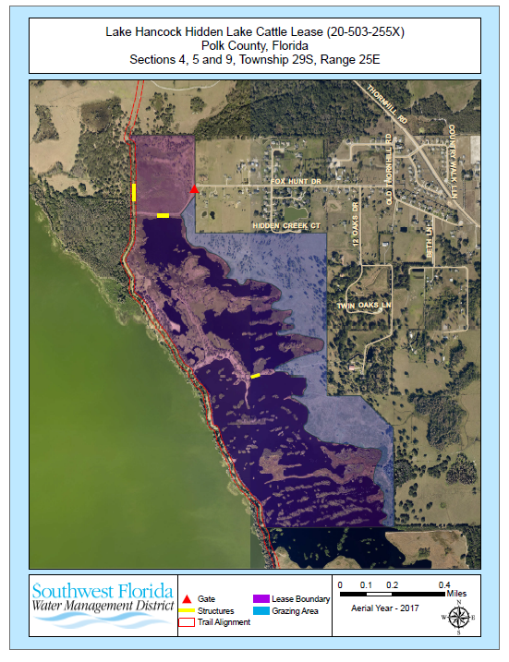

EXHIBIT “B”

Description Parcel 20-503-255X

A portion of that certain parcel of land as described as Parcel #1 and Parcel #2 in Official Records Book 6341 Pages 281-284 of the Public Records of Polk County, Florida, lying East of the Easterly line of a 100 feet wide trail known as Legacy Trail (Southwest Florida Water Management District Parcel Number 20-503-254X) and above the ordinary or mean high water line and being in Sections 4, 5 and 9, Township 29 South, Range 25 East, Polk County, Florida being more particularly described as follows:

Parcel #1:

That part of Sections 4 and 9, Township 29 South, Range 25 East, Polk County, Florida, being more particularly described as follows:

The Northwest 1/4 of the Northwest 1/4; the Southwest 1/4 of the Northwest 1/4; the South 1/2 of the Southeast 1/4 of the Northwest 1/4; the South 1/2 of the Southwest 1/4 of the Northeast 1/4; the Northwest 1/4 of the Southeast 1/4; the Southwest 1/4 of the Southeast 1/4 and that part of the Southwest 1/4 lying Northerly and Easterly of Lake Hancock, all in Section 4, Township 29 South, Range 25 East; and the North 1/2 of Section 9, Township 29 South, Range 25 East, lying East of Lake Hancock, less and except the Northeast 1/2 of the Northeast 1/4 of the Northeast 1/4 of the Northeast 1/4 of said Section 9.

Together with:

That certain appurtenant easement conveyed by USX Corporation to Bartow Rod & Reel Associates, Ltd., in the certain Warranty Deed recorded in O.R. Book 2525, page 210, as amended in O.R. Book 5665, Page 427 of the public records of Polk County, Florida.

Parcel #2:

United States Government Lot Number 3, Section 5, Township 29 South, Range 25 East, of the Public Records of Polk County, Florida.

All of the above described lands lying East of the Easterly line of a 100 feet wide trail known as Legacy Trail (Southwest Florida Water Management District Parcel Number 20-503-254X) being more particularly described as follows:

Legal Description Parcel 20-503-254X (Legacy Trail)

An easement 100 feet wide over that portion of the lands described in Official Records Book 6039 page 911 and that portion of the lands described in Official Records Book 5590 page 1816 and that portion of the lands described in Official Records Book 6341 page 281 and that portion of the lands described in Official Records Book 5334 page 2278 and that portion of the lands described in Official Records Book 7622 page 858 all in the public records of Polk County, Florida the centerline of which is described as follows:

Commence at a one and three quarters inch iron pipe marking the northeast corner of Section 25, Township 29 South, Range 24, Polk County Florida; thence North 89°33'47" West along the north boundary of said section 25 a distance of 618.90 feet to the west boundary of the aforesaid lands described in Official Records Book 6039 page 911; thence South 30°51'22" East along said west boundary a distance of 82.80 feet to the Point of Beginning, said Point of Beginning having a State Plane Coordinate value of - N 1310276.30; E 701559.43 referenced to the West Zone of the Florida State Plane Coordinate system NAD 83, 2007 adjustment, and the beginning of a curve to the right, of which the radius point lies South 33°59'49" East, a radial distance of 100.01 feet; thence easterly along the arc, through a central angle of 34°30'06", a distance of 60.22 feet; thence South 89°29'43" East, a distance of 1,145.27 feet to a point of curve to the right having a radius of 330.02 feet and a central angle of 07°14'20"; thence easterly along the arc a distance of 41.69 feet; thence South 82°15'23" East, a distance of 389.88 feet to a point of curve to the left having a radius of 330.02 feet and a central angle of
EXHIBIT “B”

07°44'37"; thence easterly along the arc a distance of 44.60 feet; thence North 90°00’00” East, a distance of 440.63 feet to a point of curve to the left having a radius of 330.02 feet and a central angle of 09°00'45"; thence easterly along the arc a distance of 51.91 feet to a point of reverse curve to the right having a radius of 330.02 feet and a central angle of 09°34'10"; thence easterly along the arc, a distance of 55.12 feet; thence South 89°26'34" East, a distance of 257.72 feet to a point of curve to the right having a radius of 100.01 feet and a central angle of 57°46'32"; thence southeasterly along the arc a distance of 100.85 feet; thence South 31°40'02" East, a distance of 55.10 feet to a point of curve to the left having a radius of 100.01 feet and a central angle of 85°28'53"; thence easterly along the arc a distance of 149.21 feet; thence North 62°51'05" East, a distance of 182.81 feet to a point of curve to the left having a radius of 50.00 feet and a central angle of 66°09'21"; thence northeasterly along the arc a distance of 57.73 feet; thence North 03°18'16" West, a distance of 33.60 feet to a point of curve to the right having a radius of 50.00 feet and a central angle of 60°17'20"; thence northeasterly along the arc a distance of 52.61 feet; thence North 56°59'04" East, a distance of 42.49 feet to a point of curve to the left having a radius of 40.00 feet and a central angle of 58°23'13"; thence northeasterly along the arc a distance of 40.76 feet; thence North 01°24'09" West, a distance of 96.69 feet to a point of curve to the left having a radius of 500.03 feet and a central angle of 12°08'58"; thence northerly along the arc a distance of 106.03 feet to a point of reverse curve to the right having a radius of 800.04 feet and a central angle of 13°33'07"; thence northerly along the arc, a distance of 189.23 feet; thence North, a distance of 354.09 feet to a point of curve to the left having a radius of 800.04 feet and a central angle of 33°40'43"; thence northerly along the arc a distance of 470.27 feet; thence North 33°40'43" West, a distance of 154.21 feet to a point of curve to the right having a radius of 1,500.08 feet and a central angle of 31°36'12"; thence northerly along the arc a distance of 827.42 feet; thence North 02°04'31" West, a distance of 494.58 feet to a point of curve to the right having a radius of 850.05 feet and a central angle of 43°48'30"; thence northerly along the arc a distance of 649.95 feet; thence North 41°44'00" East, a distance of 373.17 feet to a point of curve to the right having a radius of 100.01 feet and a central angle of 04°57'16"; thence northeasterly along the arc a distance of 8.65 feet; thence North 46°41'16" East, a distance of 207.82 feet to a point of curve to the left having a radius of 150.01 feet and a central angle of 05°13'13"; thence northeasterly along the arc a distance of 13.67 feet; thence North 41°28'03" East, a distance of 59.54 feet to a point of curve to the right having a radius of 150.01 feet and a central angle of 34°43'51"; thence northeasterly along the arc a distance of 90.93 feet; thence North 76°11'54" East, a distance of 628.13 feet to a point of curve to the right having a radius of 1,304.38 feet and a central angle of 42°11'58"; thence easterly along the arc a distance of 960.70 feet to a point of reverse curve to the left having a radius of 750.04 feet and a central angle of 08°40'29"; thence southeasterly along the arc, a distance of 113.56 feet; thence South 70°16'37" East, a distance of 1,772.34 feet to a point of curve to the right having a radius of 1,500.08 feet and a central angle of 02°05'29"; thence easterly along the arc a distance of 54.75 feet; thence South 68°11'08" East, a distance of 302.95 feet to a point of curve to the left having a radius of 1,500.08 feet and a central angle of 01°31'50"; thence easterly along the arc a distance of 40.07 feet; thence South 69°42'58" East, a distance of 73.66 feet to a point of curve to the left having a radius of 250.01 feet and a central angle of 24°20'36"; thence easterly along the arc a distance of 106.22 feet to a point of reverse curve to the right having a radius of 750.04 feet and a central angle of 03°02'20"; thence easterly along the arc, a distance of 39.78 feet; thence North 88°58'46" East, a distance of 78.77 feet to a point of curve to the right having a radius of 750.04 feet and a central angle of 03°47'54"; thence easterly along the arc a distance of 49.72 feet; thence South 87°13'20" East, a distance of 216.60 feet to a point of curve to the right having a radius of 750.04 feet and a central angle of 01°22'47"; thence easterly along the arc a distance of 18.06 feet; thence South 85°50'33" East, a distance of 440.98 feet; thence South 85°02'53" East, a distance of 879.75 feet; thence South 84°33'23" East, a distance of 543.81 feet to a point of curve to the left having a radius of 1,000.05 feet and a central angle of 04°34'14"; thence easterly along the arc a distance of 79.77 feet; thence South 89°07'37" East, a distance of 231.07 feet; thence North 90°00’00” East, a distance of 92.80 feet to a point of curve to the left having a radius of 1,000.05 feet and a central angle of 04°10'29"; thence easterly along the arc a distance of 72.87 feet; thence North 85°49'31" East, a distance of 142.16 feet to a point of curve to the left having a radius of 1,200.07 feet and a central angle of 19°25'55"; thence easterly along the arc a distance of 407.00 feet; thence North 66°23'36" East, a distance of 265.08 feet to a point of curve to the left having a radius of 1,200.07 feet and a central angle of 05°23'40"; thence northeasterly along the arc a distance of 112.99 feet; thence North 60°59'56" East, a distance of 48.56 feet to a point of curve to the right having a radius of 650.04 feet and a central angle of 33°22'34"; thence easterly along the arc a distance of 378.66 feet; thence South 85°37'30" East, a distance of 14.14 feet to a point of curve to the left having a radius of 500.03 feet and a central angle of 25°31'24"; thence easterly along the arc a distance of
EXHIBIT “B”

222.75 feet; thence North 68°51'07" East, a distance of 215.14 feet to a point of curve to the right having a radius of 500.03 feet and a central angle of 09°46'10"; thence easterly along the arc a distance of 85.26 feet; thence North 78°37'17" East, a distance of 133.63 feet to a point of curve to the right having a radius of 1,500.08 feet and a central angle of 13°24'21"; thence easterly along the arc a distance of 350.98 feet; thence South 87°58'22" East, a distance of 266.67 feet to a point of curve to the left having a radius of 1,500.08 feet and a central angle of 02°43'07"; thence easterly along the arc a distance of 71.18 feet; thence North 89°18'30" East, a distance of 323.31 feet to a point of curve to the right having a radius of 100.01 feet and a central angle of 12°48'36"; thence easterly along the arc a distance of 22.36 feet to a point of reverse curve to the left having a radius of 250.01 feet and a central angle of 27°50'56"; thence easterly along the arc, a distance of 121.52 feet; thence North 74°16'10" East, a distance of 87.08 feet to a point of curve to the left having a radius of 100.01 feet and a central angle of 72°45'43"; thence northeasterly along the arc a distance of 127.01 feet to a point of reverse curve to the right having a radius of 150.01 feet and a central angle of 32°26'06"; thence northerly along the arc, a distance of 84.92 feet; thence North 33°56'34" East, a distance of 143.07 feet to a point of curve to the left having a radius of 250.01 feet and a central angle of 46°25'52"; thence northerly along the arc a distance of 202.60 feet to a point of reverse curve to the right having a radius of 750.04 feet and a central angle of 11°50'35"; thence northerly along the arc, a distance of 155.03 feet to a point of reverse curve to the left having a radius of 750.04 feet and a central angle of 09°08'35"; thence northerly along the arc, a distance of 119.69 feet; thence North 09°47'18" West, a distance of 617.66 feet to a point of curve to the right having a radius of 900.05 feet and a central angle of 37°04'33"; thence northerly along the arc a distance of 582.42 feet to a point of reverse curve to the left having a radius of 750.04 feet and a central angle of 15°38'24"; thence northerly along the arc, a distance of 204.74 feet; thence North 11°38'51" East, a distance of 421.90 feet to a point of curve to the right having a radius of 1,250.07 feet and a central angle of 15°00'05"; thence northerly along the arc a distance of 327.30 feet; thence North 26°38'56" East, a distance of 278.30 feet to a point of curve to the right having a radius of 750.04 feet and a central angle of 08°18'22"; thence northeasterly along the arc a distance of 108.73 feet; thence North 34°57'18" East, a distance of 82.78 feet to a point of curve to the right having a radius of 330.02 feet and a central angle of 06°10'19"; thence northeasterly along the arc a distance of 35.55 feet to a point of reverse curve to the left having a radius of 330.02 feet and a central angle of 28°04'38"; thence northeasterly along the arc, a distance of 161.72 feet; thence North 13°02'59" East, a distance of 32.67 feet to a point of curve to the right having a radius of 450.02 feet and a central angle of 16°30'29"; thence northerly along the arc a distance of 129.66 feet; thence North 29°33'27" East, a distance of 97.29 feet to a point of curve to the right having a radius of 450.02 feet and a central angle of 13°36'17"; thence northeasterly along the arc a distance of 106.86 feet; thence North 43°09'45" East, a distance of 81.93 feet to a point of curve to the left having a radius of 130.01 feet and a central angle of 54°06'23"; thence northerly along the arc a distance of 122.77 feet; thence North 10°56'38" West, a distance of 90.99 feet to a point of curve to the right having a radius of 330.02 feet and a central angle of 05°08'57"; thence northerly along the arc a distance of 29.66 feet; thence North 05°47'41" West, a distance of 86.33 feet to a point of curve to the left having a radius of 330.02 feet and a central angle of 05°02'29"; thence northerly along the arc a distance of 29.04 feet; thence North 10°50'10" West, a distance of 73.08 feet to a point of curve to the right having a radius of 330.02 feet and a central angle of 10°25'30"; thence northerly along the arc a distance of 60.05 feet; thence North 00°24'40" West, a distance of 373.02 feet to a point of curve to the right having a radius of 110.01 feet and a central angle of 09°30'37"; thence northerly along the arc a distance of 18.26 feet; thence North 09°05'57" East, a distance of 346.98 feet to a point of curve to the right having a radius of 750.04 feet and a central angle of 16°04'55"; thence northerly along the arc a distance of 210.52 feet to a point of reverse curve to the left having a radius of 330.02 feet and a central angle of 30°30'42"; thence northerly along the arc, a distance of 175.74 feet; thence North 05°19'50" West, a distance of 81.09 feet to a point of curve to the left having a radius of 330.02 feet and a central angle of 08°50'44"; thence northerly along the arc a distance of 50.95 feet to a point of reverse curve to the right having a radius of 330.02 feet and a central angle of 07°45'23"; thence northerly along the arc, a distance of 44.68 feet; thence North 06°25'11" West, a distance of 49.60 feet to a point of curve to the left having a radius of 330.02 feet and a central angle of 09°30'52"; thence northerly along the arc a distance of 54.80 feet to a point of reverse curve to the right having a radius of 330.02 feet and a central angle of 23°36'19"; thence northerly along the arc, a distance of 135.96 feet; thence North 07°40'15" East, a distance of 122.61 feet to a point of curve to the right having a radius of 150.01 feet and a central angle of 16°09'59"; thence northerly along the arc a distance of 42.33 feet; thence North 23°50'14" East, a distance of 81.39 feet to a point of curve to the left having a radius of 110.01 feet and a central angle of 35°02'38"; thence northerly along the arc a distance of 67.29 feet to a point of reverse curve to the right having
EXHIBIT “B”

a radius of 110.01 feet and a central angle of 23°38'08"; thence northerly along the arc, a distance of 45.38 feet; thence North 12°25'43" East, a distance of 75.30 feet to a point of curve to the left having a radius of 110.01 feet and a central angle of 14°46'12"; thence northerly along the arc a distance of 28.36 feet; thence North 02°20'29" West, a distance of 47.59 feet to a point of curve to the left having a radius of 150.01 feet and a central angle of 35°37'40"; thence northerly along the arc a distance of 93.28 feet to a point of reverse curve to the right having a radius of 110.01 feet and a central angle of 61°25'18"; thence northerly along the arc, a distance of 117.93 feet to a point of reverse curve to the left having a radius of 110.01 feet and a central angle of 51°02'23"; thence northerly along the arc, a distance of 98.00 feet to a point of reverse curve to the right having a radius of 110.01 feet and a central angle of 24°05'18"; thence northerly along the arc, a distance of 46.25 feet; thence North 03°29'55" West, a distance of 141.50 feet to a point of curve to the right having a radius of 150.01 feet and a central angle of 31°15'09"; thence northerly along the arc a distance of 81.82 feet to a point of reverse curve to the left having a radius of 110.01 feet and a central angle of 22°31'13"; thence northerly along the arc, a distance of 43.24 feet; thence North 05°14'01" East, a distance of 101.18 feet to a point of curve to the left having a radius of 150.01 feet and a central angle of 22°09'58"; thence northerly along the arc a distance of 58.03 feet; thence North 16°55'57" West, a distance of 66.17 feet to a point of curve to the right having a radius of 150.01 feet and a central angle of 25°37'30"; thence northerly along the arc a distance of 67.09 feet; thence North 08°41'33" East, a distance of 91.31 feet to a point of curve to the right having a radius of 330.02 feet and a central angle of 27°09'52"; thence northerly along the arc a distance of 156.47 feet; thence North 35°51'25" East, a distance of 72.88 feet to a point of curve to the left having a radius of 110.01 feet and a central angle of 49°54'51"; thence northerly along the arc a distance of 95.84 feet; thence North 14°03'26" West, a distance of 126.92 feet to a point of curve to the right having a radius of 450.02 feet and a central angle of 30°57'19"; thence northerly along the arc a distance of 243.13 feet; thence North 16°53'53" East, a distance of 120.00 feet to a point of curve to the right having a radius of 450.02 feet and a central angle of 13°42'54"; thence northeasterly along the arc a distance of 107.72 feet; thence North 30°36'47" East, a distance of 104.52 feet to a point of curve to the left having a radius of 150.01 feet and a central angle of 68°02'56"; thence northerly along the arc a distance of 178.16 feet; thence North 37°26'09" West, a distance of 134.95 feet to a point of curve to the right having a radius of 150.01 feet and a central angle of 40°20'21"; thence northerly along the arc a distance of 105.61 feet to a point of reverse curve to the left having a radius of 150.01 feet and a central angle of 24°00'21"; thence northerly along the arc, a distance of 62.85 feet; thence North 21°06'08" West, a distance of 450.09 feet to a point of curve to the right having a radius of 550.03 feet and a central angle of 10°38'32"; thence northerly along the arc a distance of 102.16 feet to a point of reverse curve to the left having a radius of 550.03 feet and a central angle of 20°53'48"; thence northerly along the arc, a distance of 200.60 feet to a point of reverse curve to the right having a radius of 550.03 feet and a central angle of 07°32'18"; thence northwesterly along the arc, a distance of 72.37 feet; thence North 23°49'06" West, a distance of 44.65 feet to a point of curve to the right having a radius of 330.02 feet and a central angle of 04°20'05"; thence northerly along the arc a distance of 24.97 feet; thence North 19°29'01" West, a distance of 133.13 feet to a point of curve to the right having a radius of 110.01 feet and a central angle of 30°06'01"; thence northerly along the arc a distance of 57.79 feet to a point of reverse curve to the left having a radius of 150.01 feet and a central angle of 38°21'05"; thence northerly along the arc, a distance of 100.41 feet; thence North 27°44'05" West, a distance of 130.80 feet to a point of curve to the right having a radius of 550.03 feet and a central angle of 27°35'26"; thence northerly along the arc a distance of 264.87 feet; thence North 00°08'39" West, a distance of 128.81 feet to a point of curve to the left having a radius of 110.01 feet and a central angle of 43°55'34"; thence northerly along the arc a distance of 84.34 feet; thence North 44°04'13" West, a distance of 222.44 feet to a point of curve to the right having a radius of 550.03 feet and a central angle of 13°33'07"; thence northwesterly along the arc a distance of 130.10 feet to a point of reverse curve to the left having a radius of 110.01 feet and a central angle of 25°57'48"; thence northwesterly along the arc, a distance of 49.85 feet; thence North 56°28'54" West, a distance of 42.56 feet to a point of curve to the right having a radius of 150.01 feet and a central angle of 23°40'32"; thence northwesterly along the arc a distance of 61.99 feet; thence North 32°48'21" West, a distance of 187.71 feet to a point of curve to the right having a radius of 550.03 feet and a central angle of 24°19'44"; thence northerly along the arc a distance of 233.55 feet; thence North 08°28'37" West, a distance of 53.73 feet to a point of curve to the left having a radius of 150.01 feet and a central angle of 20°17'30"; thence northerly along the arc a distance of 53.13 feet; thence North 28°46'07" West, a distance of 83.38 feet to a point of curve to the right having a radius of 150.01 feet and a central angle of 12°45'15"; thence northerly along the arc a distance of 33.39 feet to a point of reverse curve to the left having a radius of 150.01 feet and a central angle of 15°25'23"; thence northwesterly along the arc, a
EXHIBIT “B”

distance of 40.38 feet; thence North 31°26'15" West, a distance of 80.50 feet to a point of curve to the right having a radius of 250.01 feet and a central angle of 07°42'29"; thence northwesterly along the arc a distance of 33.63 feet; thence North 23°43'45" West, a distance of 235.96 feet to a point of curve to the right having a radius of 250.01 feet and a central angle of 12°34'08"; thence northerly along the arc a distance of 54.84 feet to a point of reverse curve to the left having a radius of 250.01 feet and a central angle of 06°34'41"; thence northerly along the arc, a distance of 28.70 feet; thence North 17°44'18" West, a distance of 157.07 feet to a point of curve to the left having a radius of 30.00 feet and a central angle of 68°53'18"; thence northwesterly along the arc a distance of 36.07 feet to a point of reverse curve to the right having a radius of 100.01 feet and a central angle of 73°49'25"; thence northwesterly along the arc, a distance of 128.86 feet; thence North 12°48'11" West, a distance of 148.22 feet to a point of curve to the right having a radius of 150.01 feet and a central angle of 27°22'26"; thence northerly along the arc a distance of 71.67 feet to a point of reverse curve to the left having a radius of 150.01 feet and a central angle of 31°38'45"; thence northerly along the arc, a distance of 82.85 feet; thence North 17°04'30" West, a distance of 87.55 feet to a point of curve to the right having a radius of 850.05 feet and a central angle of 13°36'51"; thence northerly along the arc a distance of 201.98 feet to a point of reverse curve to the left having a radius of 150.01 feet and a central angle of 33°08'25"; thence northerly along the arc, a distance of 86.77 feet; thence North 36°36'03" West, a distance of 108.78 feet to a point of curve to the left having a radius of 110.01 feet and a central angle of 29°31'14"; thence northwesterly along the arc a distance of 56.68 feet to a point of reverse curve to the right having a radius of 110.01 feet and a central angle of 32°17'33"; thence northwesterly along the arc, a distance of 62.00 feet; thence North 33°49'44" West, a distance of 188.96 feet to a point of curve to the right having a radius of 110.01 feet and a central angle of 32°27'01"; thence northerly along the arc a distance of 62.31 feet to a point of reverse curve to the left having a radius of 110.01 feet and a central angle of 62°30'10"; thence northwesterly along the arc, a distance of 120.01 feet to a point of reverse curve to the right having a radius of 330.02 feet and a central angle of 30°05'46"; thence northwesterly along the arc, a distance of 173.35 feet; thence North 33°47'07" West, a distance of 95.05 feet to a point of curve to the right having a radius of 330.02 feet and a central angle of 20°13'42"; thence northwesterly along the arc a distance of 116.51 feet to a point of reverse curve to the left having a radius of 330.02 feet and a central angle of 20°54'35"; thence northwesterly along the arc, a distance of 120.44 feet; thence North 34°28'01" West, a distance of 222.92 feet to a point of curve to the right having a radius of 330.02 feet and a central angle of 09°07'42"; thence northwesterly along the arc a distance of 52.58 feet to a point of reverse curve to the left having a radius of 330.02 feet and a central angle of 14°01'21"; thence northwesterly along the arc, a distance of 80.77 feet; thence North 39°21'39" West, a distance of 144.77 feet to a point of curve to the right having a radius of 330.02 feet and a central angle of 06°02'48"; thence northwesterly along the arc a distance of 34.83 feet; thence North 33°18'52" West, a distance of 132.82 feet to a point of curve to the left having a radius of 330.02 feet and a central angle of 07°28'51"; thence northwesterly along the arc a distance of 43.09 feet to a point of reverse curve to the right having a radius of 330.02 feet and a central angle of 08°53'21"; thence northwesterly along the arc, a distance of 51.20 feet; thence North 31°54'22" West, a distance of 215.71 feet to a point of curve to the left having a radius of 850.05 feet and a central angle of 17°31'12"; thence northwesterly along the arc a distance of 259.93 feet; thence North 49°25'33" West, a distance of 104.52 feet to a point of curve to the right having a radius of 150.01 feet and a central angle of 54°10'17"; thence northerly along the arc a distance of 141.83 feet; thence North 04°44'44" East, a distance of 182.69 feet to a point of curve to the left having a radius of 110.01 feet and a central angle of 34°07'39"; thence northerly along the arc a distance of 65.53 feet; thence North 29°22'56" West, a distance of 305.61 feet to a point of curve to the right having a radius of 150.01 feet and a central angle of 57°48'44"; thence northerly along the arc a distance of 151.36 feet; thence North 28°25'48" East, a distance of 278.41 feet to a point of curve to the left having a radius of 330.02 feet and a central angle of 32°42'13"; thence northerly along the arc a distance of 188.37 feet to a point of reverse curve to the right having a radius of 330.02 feet and a central angle of 06°42'59"; thence northerly along the arc, a distance of 38.69 feet; thence North 02°26'34" East, a distance of 397.35 feet to a point of curve to the left having a radius of 850.05 feet and a central angle of 02°57'07"; thence northerly along the arc a distance of 43.79 feet; thence North 00°30'33" West, a distance of 658.62 feet to a point of curve to the right having a radius of 330.02 feet and a central angle of 10°16'46"; thence northerly along the arc a distance of 59.21 feet to a point of reverse curve to the left having a radius of 330.02 feet and a central angle of 13°59'03"; thence northerly along the arc, a distance of 80.55 feet; thence North 04°12'50" West, a distance of 64.94 feet to a point of curve to the right having a radius of 330.02 feet and a central angle of 11°04'14"; thence northerly along the arc a distance of 63.76 feet to a point of reverse curve to the left having a radius of 330.02 feet and a central angle of 19°22'13";
EXHIBIT “B”

thence northerly along the arc, a distance of 111.57 feet to a point of reverse curve to the right having a radius of 330.02 feet and a central angle of 08°24'34"; thence northerly along the arc, a distance of 48.44 feet; thence North 04°06'15" West, a distance of 87.76 feet to a point of curve to the right having a radius of 330.02 feet and a central angle of 07°42'09"; thence northerly along the arc a distance of 44.37 feet; thence North 03°35'55" East, a distance of 120.33 feet to a point of curve to the left having a radius of 50.00 feet and a central angle of 66°48'02"; thence northwesterly along the arc a distance of 58.29 feet; thence North 63°12'07" West, a distance of 54.87 feet to a point of curve to the right having a radius of 92.01 feet and a central angle of 77°16'10"; thence northwesterly along the arc a distance of 124.09 feet; thence North 14°04'03" East, a distance of 166.44 feet to a point of curve to the right having a radius of 110.01 feet and a central angle of 31°00'04"; thence northeasterly along the arc a distance of 59.52 feet to a point of reverse curve to the left having a radius of 110.01 feet and a central angle of 31°00'04"; thence northeasterly along the arc, a distance of 59.52 feet; thence North 14°04'03" East, a distance of 516.23 feet; thence North 09°47'01" East, a distance of 941.67 feet to a point of curve to the right having a radius of 110.01 feet and a central angle of 54°19'36"; thence northeasterly along the arc a distance of 104.31 feet to a point of reverse curve to the left having a radius of 110.01 feet and a central angle of 65°49'08"; thence northeasterly along the arc, a distance of 126.37 feet; thence North 01°42'31" West, a distance of 155.05 feet to a point of curve to the right having a radius of 330.02 feet and a central angle of 03°18'27"; thence northerly along the arc a distance of 19.05 feet; thence North 01°35'55" East, a distance of 441.60 feet to a point of curve to the right having a radius of 102.01 feet and a central angle of 86°59'59"; thence northeasterly along the arc a distance of 154.90 feet; thence North 88°35'54" East, a distance of 142.72 feet to a point of curve to the right having a radius of 550.03 feet and a central angle of 09°07'28"; thence easterly along the arc a distance of 87.59 feet to a point of reverse curve to the left having a radius of 550.03 feet and a central angle of 06°36'53"; thence easterly along the arc, a distance of 63.50 feet; thence South 88°53'30" East, a distance of 790.32 feet to a point of curve to the left having a radius of 110.01 feet and a central angle of 130°34'39"; thence northeasterly along the arc a distance of 250.71 feet; thence North 39°28'09" West, a distance of 67.74 feet to a point of curve to the left having a radius of 250.01 feet and a central angle of 34°46'44"; thence northwesterly along the arc a distance of 151.76 feet to a point of reverse curve to the right having a radius of 250.01 feet and a central angle of 28°37'58"; thence northwesterly along the arc, a distance of 124.94 feet; thence North 45°36'54" West, a distance of 254.52 feet to a point of curve to the left having a radius of 330.02 feet and a central angle of 20°41'33"; thence northwesterly along the arc a distance of 119.19 feet to a point of reverse curve to the right having a radius of 330.02 feet and a central angle of 20°38'56"; thence northwesterly along the arc, a distance of 118.94 feet; thence North 45°39'32" West, a distance of 137.73 feet to a point of curve to the right having a radius of 150.01 feet and a central angle of 25°49'20"; thence northwesterly along the arc a distance of 67.61 feet to a point of reverse curve to the left having a radius of 150.01 feet and a central angle of 35°30'10"; thence northwesterly along the arc, a distance of 92.95 feet; thence North 55°20'22" West, a distance of 95.61 feet to a point of curve to the right having a radius of 150.01 feet and a central angle of 09°51'01"; thence northwesterly along the arc a distance of 25.79 feet; thence North 45°29'21" West, a distance of 308.90 feet to a point of curve to the right having a radius of 110.01 feet and a central angle of 133°45'32"; thence northerly along the arc a distance of 256.82 feet; thence North 88°16'10" East, a distance of 72.48 feet to a point of curve to the left having a radius of 330.02 feet and a central angle of 09°51'56"; thence easterly along the arc a distance of 56.82 feet; thence North 78°24'15" East, a distance of 335.98 feet to a point of curve to the right having a radius of 330.02 feet and a central angle of 05°53'52"; thence easterly along the arc a distance of 33.97 feet; thence North 84°18'07" East, a distance of 133.34 feet to a point of curve to the left having a radius of 330.02 feet and a central angle of 20°55'21"; thence easterly along the arc a distance of 120.51 feet; thence North 63°22'46" East, a distance of 61.38 feet to the west right of way line of
Thornhill Road according to Maintained Right of Way Map Book 2 pages 266-272 of the Public Records of Polk County Florida, and the east boundary of the lands described in aforesaid Official Records Book 7622 page 858, and the terminus of said centerline. Said terminus bears South 50°50'04" East a distance of 1864.59 feet from a 4”x4” concrete monument marking the northeast corner of Section 32, Township 28 South, Range 25 East, Polk County Florida. Said terminus having a State Plane Coordinate value of - N 1335589.84; E 713996.83 referenced to the West Zone of the Florida State Plane Coordinate system NAD 83, 2007 adjustment

The sidelines of said 100 foot easement to be extended or shortened as necessary to intersect at angle points, points of curvature, points of tangency and to terminate at said west right of way line of Thornhill Road and the east boundary of the lands described in Official Records Book 7622 page 858 and extended or shortened to
EXHIBIT “B”

terminate at the aforesaid west boundary of the lands described in Official Records Book 6039 page 911. Described lands contain 4,348,407 square feet or 99.82 acres.

Approved for use by the Survey Section 08-25-2014, W.O. 14-131.

Remainder of this page intentionally left blank.

EXHIBIT “C”
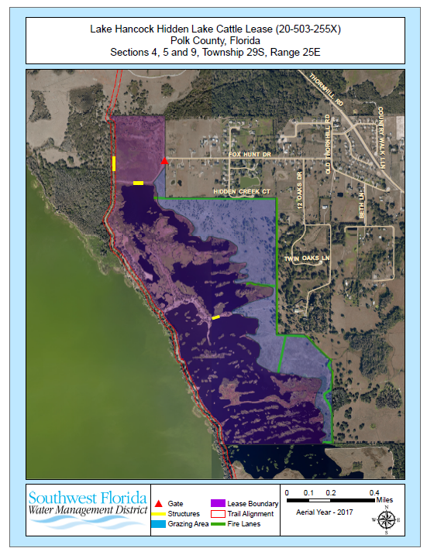

ATTACHMENT 4

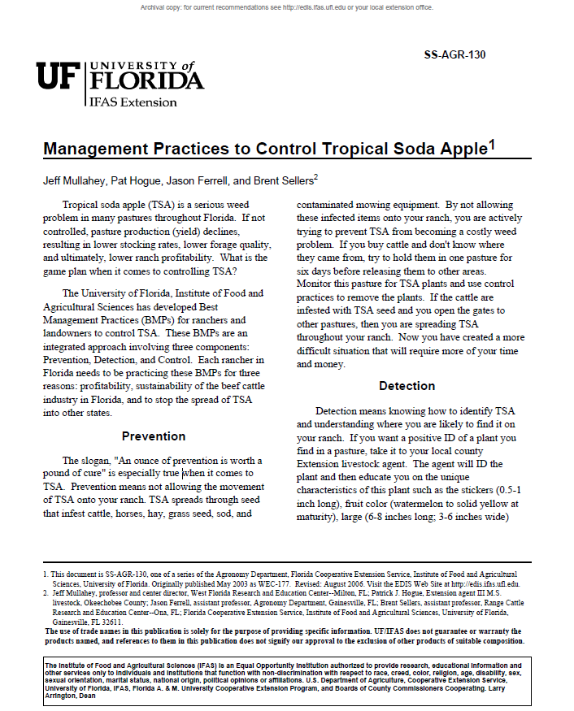

ATTACHMENT 4 (Cont.)

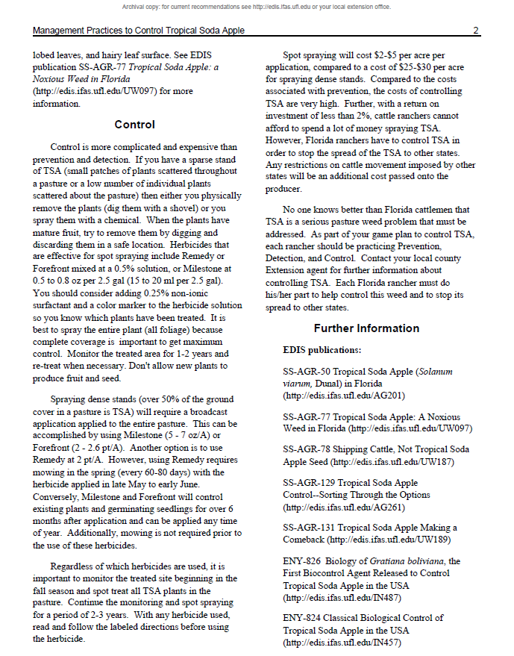

ATTACHMENT 4 (Cont.)

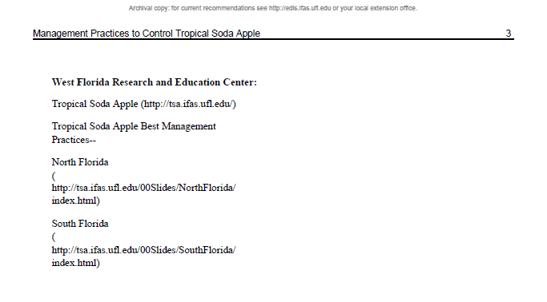

ATTACHMENT 5

ATTACHMENT 5 (Cont.)

ATTACHMENT 5 (Cont.)

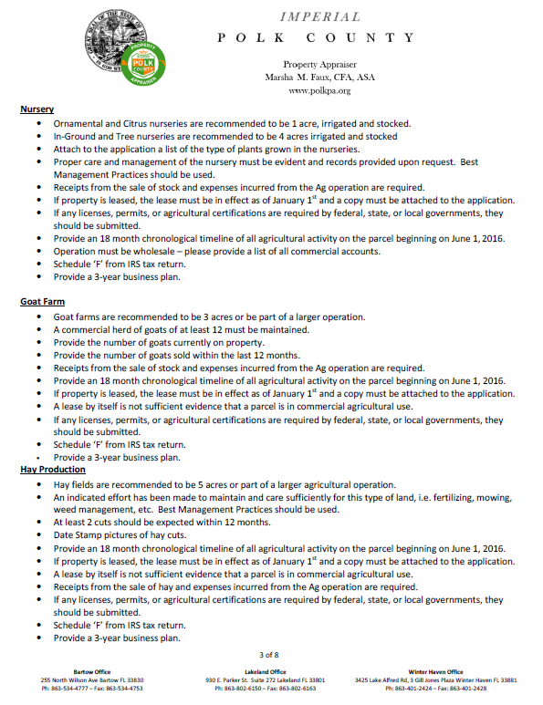

ATTACHMENT 5 (Cont.)

ATTACHMENT 5 (Cont.)

ATTACHMENT 5 (Cont.)

ATTACHMENT 5 (Cont.)

ATTACHMENT 5 (Cont.)

