2019 Water Audit Report

City of XXXX Utilities
Address
Address, FL

Utility System Name
Water Use Permit No. XXXX

WATER LOSS SUMMARY

Provide basic information about the primary types of water loss experienced by the utility. Provide information about the utility system that is useful to understanding the types of water use and water loss in that utility. The narrative should answer the following types of questions:

- What are the potential factors contributing to overall water loss?
- What’s the system history/background as it relates to water loss?
- What are potential sources of uncertainty in estimating water loss? Does the utility have enough information at this time to make informed decisions on reducing water loss?

Some information that may be useful includes:
- Description of the utility infrastructure, such as location, pipe materials, and relative age of infrastructure
- Listing of various water treatment plants in the system
- Water source and treatment processes
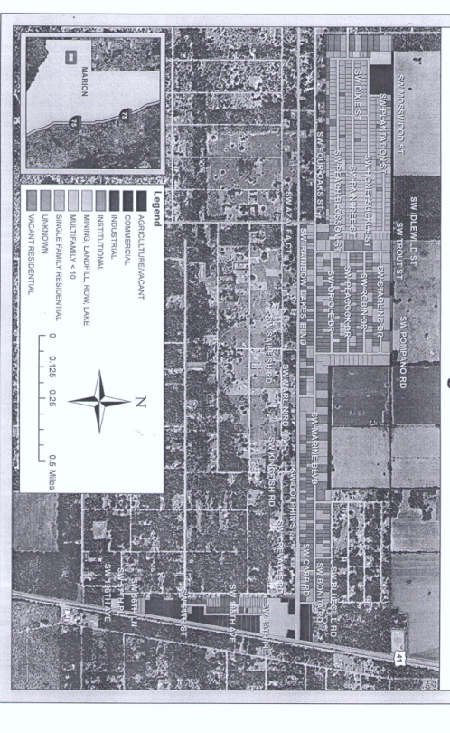
- Source water quality and finished water quality (particularly if flushing is a large water use)
- A map (or several small maps) of the utility system may be useful as an attachment

2019 WATER AUDIT RESULTS

Discuss the results of the current water audit. Water loss should be broken down into estimated volumes for each type of loss. Discuss how confident the utility staff are in the estimates of different sources of loss. It may be good to break this section down into types of water use and water loss such as:

- Authorized Consumption
  - Billed Metered Consumption
  - Billed Unmetered Consumption (if applicable)
  - Authorized Non-Revenue Water Consumption (including utility uses)
  - Main Flushing for Water Quality
- Real Loss
  - Accounted Tank Overflows/Leakage
  - Accounted Main Breaks and Repaired Leaks
  - Distribution System Leakage
- Apparent Losses
  - Customer Metering Inaccuracies
  - Unauthorized Consumption
  - Supply Meter Inaccuracies
  - Systematic Reporting Errors

WATER LOSS CONTROL PROGRAM

Provide general information on recent/current utility operations and how they relate to water loss. What are some factors that that have led to different types of water loss in the past few years? What is currently being done to quantify and reduce water loss? Useful information may include:

- Utility priorities for water loss control
- Infrastructure repairs/replacement
- Changes to billing practices and service meters
- Service meter replacement program
- Changes in treatment processes or utility operations
- Existing water quality issues and flushing practices

REMEDIAL ACTION PLAN

Create a plan to reduce water losses to below 10%. Discuss how the different sources of loss in the system can be reduced and better quantified. The timeframe of reducing losses will be based on the types of loss and the different actions or practices required to reduce those losses, as well as utility resources.

SOPs and Action Items

Fill out the table below to list SOPs and utility improvements that can help to reduce water loss or better quantify difference sources or water loss or consumption, based on the results of the water audit. Only list SOPs that relate to the losses occurring in the system. Don’t fill up the list with SOPs the utilities is already practicing.

TASK | DESCRIPTION | START DATE | COMPLETION DATE
1 | Conduct a meter survey to assess service meter accuracy. | October 1, 2015 | September 31, 2016
2 | Implement and SOP to evaluate Customer/Service meters on a monthly basis using low or no consumption reports to determine which need to be replaced. | October 1, 2015 | Ongoing
3 | Provide the fire department with a hydrant meter and designated fill station for training. | October 1, 2015 | Ongoing
5 | Perform semi-annual inspections of all isolated areas of the distribution system via walking survey to inspect for leaks and theft. | October 1, 2015 | Ongoing
6 | Install meters on 28 unmetered autoflushers to better quantify flushing volumes. | October 1, 2015 | September 31, 2016
7 | Implement a unidirectional flushing program to reduce flushing demands. | October 1, 2015 | September 31, 2016
8 | Update the billing software and provide training to billing/reporting staff. | October 1, 2015 | Jan 1, 2016
9 | Work with SWFWMD to conduct a leak detection survey of the South service area. | October 1, 2015 | March 31, 2016

